Servista
Broad Range of SERVICES

Tehreem Aman 2022-js-317
Meerab Tasleem 2022-js-213
Kashaf Mubarak 2022-js-286

Under the Supervision of:
Prof. Abu Zar Tamimi

Bachelor of Science in Information Technology
Session (2022-2026).
Department of Information Technology

A Project represented to
University of the Punjab, Lahore.

STATEMENT OF SUBMISSION
This is to certify that the following students have successfully completed the final year project titled “Servista” at Govt. Jinnah Islamia College, Sialkot,
In partial fulfilment
of the requirement for the degree of
Bachelor of Science in Information Technology,
Session (2022-2026).
By
Name of student  Tehreem Aman  Meerab Tasleem  Kashaf Mubarak | Roll number  090467  090451  090486

Department of Information Technology

DECLARATION
We hereby declare that the project titled “Servista” is an original work carried out by us. This software and its accompanying documentation have been developed entirely based on our own efforts and ideas. No part of this project has been copied or taken from any existing source, software, or project.
If any part of this work is later found to be reproduced or copied from another source, we shall take full responsibility for the consequences. Furthermore, this project has not been submitted for any other degree or qualification at any other university or institute of learning.

Signature___________
Tehreem Aman

Signature___________
Meerab Tasleem

Signature__________
Kashaf Mubarak

CERTIFICATE OF APPROVAL
It is to certify that the final year Project (FYP) of BSIT, session (2022-2026), titled “Servista: An All-in-one Service providing platform” was developed by Tehreem Aman, Meerab Tasleem & Kashaf Mubarak under the supervision of Prof. Abu Zar Tamimi.
In my opinion, this project after careful evaluation, the project has been found complete, well-developed, and suitable in both scope and quality for the degree of Bachelor of Science in Information Technology. The project successfully presents an online platform where users can easily hire professionals for different home and technical services such as cleaning, plumbing, electrician work, tutoring, and maintenance.

FYP Advisor: Prof Abu Zar Tamimi Sb.
Advisor’s Signature: _____________________

Head of Department: Prof. Mussadiq Fida Sb.
HOD’s Signature: ____________________

EXECUTIVE SUMMARY
The main goal of Servista is to make it simple and quick for anyone to get reliable services without wasting time searching or calling multiple people. Through this platform, customers can book services online, check prices, and even review the service quality. On the other hand, service providers can register on the platform to offer their services and grow their business.
Servista is designed using modern web technologies to ensure it runs smoothly and securely. It includes features like user registration, service booking, admin control, and real-time communication between customers and workers.
Unlike traditional methods where finding help is time-consuming, Servista provides a digital and organized way to get things done making life easier for both customers and service providers.
In short, Servista is a smart, user-friendly, and trustworthy platform that brings all kinds of services to your fingertips, helping people save time, effort, and money through an easy online solution.
Keywords: Servista, web technologies, admin control, trustworthy.

ACKNOWLEDGEMENT
First, we thank Almighty Allah for giving us the strength and ability to complete our final year project, “Servista: An All-in-One Service Providing Platform.”
We are very thankful to our respected supervisor, Prof. Abu Zar Tamimi, for his kind guidance, help, and throughout this project. His advice and encouragement made this work possible.
We also thank all our teachers for sharing their knowledge and helping us learn the skills needed for this project.
Special thanks to our friends and classmates for their ideas, motivation, and support.
Lastly, we are grateful to our families for their continuous love, prayers, and encouragement that kept us going until the end support.

Signature: ___________
Tehreem Aman
Signature: ___________
Meerab Tasleem
Signature: __________
Kashaf Mubarak

ABBRIVATIONS
BSIT | Bachelor of Science in Information Technology
FYPD | Final Year Project Documentation
UI | User Interface
SRS | Software Requirement Specification
URL | Uniform Resource Locator
HTTPS | Hypertext Transfer Protocol
ERD | Entity Relationship Diagram
API | Application Programming Interface
Table 1 abbrivations

Table of Contents
EXECUTIVE SUMMARY 5
ACKNOWLEDGEMENT 6
ABBRIVATIONS 7
Chapter 1 14
Introduction 14
1. Introduction 15
1.1. Problem Statement 15
1.2. Problem Solution 15
1.3. Objectives of the Proposed System 16
1.4. Scope 16
1.5. System Components 18
1.5.1. Module 1: customer Panel 19
1.5.2. Module 2: Service provider Panel 19
1.5.3. Module 3: Admin Panel 20
1.6. Related System Analysis/Literature Review 20
1.7. Vision Statement 21
1.8. System Limitations and Constraints 21
1.9. Tools and Technologies 22
1.10. Project Deliverables 22
1.11. Project Planning 23
1.13. Summary 23
Chapter 2 25
Requirements Analysis 25
2. Analysis 26
2.1. User classes and characteristics 26
2.2. Requirement Identifying Technique 26
2.2.1. Use Case Diagram 27
2.2.2 Use Case #2: Search and Filter Services 29
2.2.3Use Case #3: Book a Service 29
2.2.4 Use Case #4: Manage Service Availability 30
2.2.5 Use Case #5: Payment and Confirmation 30
2.3. Functional Requirements 30
2.3.1. Functional Requirement FR-1: User Registration and authentication 31
2.3.2. Functional Requirement FR-2: Service browsing and search 31
2.3.3. Functional Requirement FR-3: Service Booking 31
2.3.4. Functional Requirements FR-4: Provider Availability Management 32
2.3.5. Functional Requirements FR-5: Real time Service Tracking 32
2.3.6. Functional Requirements FR-6: Secure Payment Processing 32
2.3.7. Functional Requirements FR-7: Ratings and Reviews System 33
2.3.8. Functional Requirements FR-8: Admin Management Dashboard 33
2.3.9. Functional Requirements FR-9: Notification system 33
2.3.10. Functional Requirements FR-10: Service History Management 34
2.4. Non-Functional Requirements 34
2.4.1 Performance Requirements 34
2.4.2 Security Requirements 34
2.4.3 Usability Requirements 35
2.4.4 Reliability Requirements 35
2.4.5 Scalability Requirements 35
2.4.6 Maintainability Requirements 35
2.4.7 Availability Requirements 35
2.4.8 Compatibility Requirements 35
Chapter 3 36
Design and Architecture 36
3.1 System Design 37
3.2 Design Considerations: 38
3.3 Design Models: 38
3.3.2. Sequence Diagram: 40
3.3.3 State Transition Diagram: 44
3.4 Architectural Design: 45
3.5 Data Design 49
3.5.1. Data Dictionary 50
3.6. User Interface Design 53
3.6.1. Screen Objects and Actions 57
3.7. Design Decisions 58
3.8 Summary 60
Chapter 04 61
Implementation 61
4. Implementation: 62
4.1. Algorithm 62
4.2 Code Repository: 64
4.2.1 Metrics of the Git Repository 65
4.3 Summary: 65
Chapter 5 66
Testing and Evaluation 66
5. Introduction 67
5.1. Unit testing 67
5.2. Functional Testing 70
5.3 Integration Testing (IT) 73
5.4. Performance Testing (PT) 77
5.5. Summary 80
Chapter 6 82
System Conversion 82
6. Introduction 83
6.1. Conversion Method 83
6.2. Deployment 83
6.2.1. Data Conversion: 84
6.2.2. Training: 84
6.3. Post Deployment Testing 84
6.4. Challenges: 84
6.5. Summary 85
Chapter 7 86
Conclusion 86
7. Introduction 87
7.1. Evaluation: 87
7.2. Traceability matrix 87
7.3. Conclusion: 88
7.4. Future work: 89
References: 89

Figure 1 Project planning 23
Figure 2 Gantt Chart 23
Figure 3 Customer use case diagram 27
Figure 4 Service providers use case Diagram 28
Figure 5 Admin use case Diagram 28
Figure 6 UML Class Diagram 39
Figure 7 User Authentication Sequence Diagram 40
Figure 8 Service Search Sequence Diagram 41
Figure 9 Service Booking Sequence Diagram 41
Figure 10 Payment Processing Sequence Diagram 42
Figure 11 Messaging Sequence Diagram 42
Figure 12 Service Completion & History Sequence Diagram 43
Figure 13 State Transition Diagram 44
Figure 14 Block Diagram 46
Figure 15 Database Diagram 47
Figure 16 Deployment Diagram 48
Figure 17 Sign in screen 54
Figure 18 Login screens 57

Table 1 abbrivations 7
Table 2 Related System Analysis/Literature Review 20
Table 3 Related System Analysis/Literature Review 21
Table 4 Tools and Technologies 22
Table 5 User classes and characteristics 26
Table 6 Use case Name and Associated Requirements 27
Table 7 Use Case # 1: User Registration and Authentication 29
Table 8 Use Case #2: Search and Filter Services 29
Table 9 Use Case #3: Book a Service 30
Table 10 Use Case #4: Manage Service Availability 30
Table 11 Use Case #5: Payment and Confirmation 30
Table 12 Functional Requirement FR-1: User Registration and authentication 31
Table 13 Functional Requirement FR-2: Service browsing and search 31
Table 14 Functional Requirement FR-3: Service Booking 32
Table 15 Functional Requirements FR-4: Provider Availability Management 32
Table 16 Functional Requirements FR-5: Real time Service Tracking 32
Table 17 Functional Requirements FR-6: Secure Payment Processing 33
Table 18 Functional Requirements FR-7: Ratings and Reviews System 33
Table 19 Functional Requirements FR-8: Admin Management Dashboard 33
Table 20 Functional Requirements FR-9: Notification system 34
Table 21 Functional Requirements FR-10: Service History Management 34
Table 22 Assumptions and Dependencies 38
Table 23 Limitations 38
Table 24 Use Case 1: book a Service (customer side) 57
Table 25 Use case 2: Manage Services (Provider Side) 58
Table 26 Use case 3: Admin dashboard (Admin side) 58
Table 27 Algorithms 64
Table 28 Metrics of the Git Repository 65
Table 29 Unit test case 1 67
Table 30 Unit Case Test 2 68
Table 31 Unit Case Test 3 68
Table 32 Unit Test Case 4 69
Table 33 Unit Test Case 5 69
Table 34 F.T case 1 – User Registration (Customer /Provider) 70
Table 35 F.T case 2 –Service search with Filters 71
Table 36 F.T case 3-Book a Service 71
Table 37 F.T case 4- Secure Payment processing 72
Table 38 F.T case 5- Admin Approves a Service Provider 72
Table 39 F.T case 6- Chatbot service support 73
Table 40 F.T case 7-Rating and Review Submission 73
Table 41 IT case 1-Service Booking and Provider Acceptance integration` 74
Table 42 IT Case 2-Payment and Booking Confirmation Integration 75
Table 43 Use case 3- service completing and Rating Integration 75
Table 44 IT Case 4-Chatbot and Service Search Integration 76
Table 45 IT Case5- Admin Approval and Provider Login Integration 76
Table 46 IT Case6-Booking and Notification Integration 77
Table 47 PT Case 1 77
Table 48 PT Case 2 78
Table 49 PT Case 3 78
Table 50 PT Case 4 79
Table 51 PT Case 5 79
Table 52 PT Case 6 80
Table 53 PT Case 7 80
Table 54 Evaluation 87
Table 55 Traceability matrix 88
Table 56 Objective and functionality table 89

Chapter 1

Introduction

1. Introduction
Life gets busy, keeping up with household chores can be overwhelming, but Servista is here to make life easier. We bring together trusted experts for cleaning, plumbing, painting, stitching, solar maintenance, Pest control and many other home services in all-in-one places. At Servista, we make it easy for you to get things done around the house without the stress. Whether you need help with cleaning, plumbing, painting, stitching, solar maintenance, or any other household task, we’ve got trusted professionals ready to help. We believe in quality work, fair prices, and friendly service. Just tell us what you need, and we’ll take care of the rest so you can enjoy a clean, safe, and well-maintained home. Our platform is designed to be simple and user-friendly, so booking a service takes just a few clicks. You’ll find detailed profiles, honest reviews, discounts and clear pricing no surprises, no confusion.
At Servista, we care about your comfort and peace of mind. That’s why we only work with verified experts who treat your home like their own. Whether it’s a quick fix or a big project, we’re here to make your life easier. So, sit back, relax, and let Servista handle the chores because your time is valuable, and your home deserves the best.

1.1. Problem Statement
People often struggle to find good and reliable help for everyday tasks like cleaning, plumbing, stitching, painting, and home repairs. Most of the time, they must visit service providers in person or call them manually, which takes a lot of time and causes delays. Even online platforms don’t make things easy. They don’t match customers with the right service providers based on location, availability, or skills. This leads to confusion, missed appointments, and poor service. Another big issue is communication. Customers can’t easily talk to service providers to ask questions or get updates. That’s why our platform will include live chat, so people can connect instantly and get things done faster. Also, there’s no proper way to check if a service provider is trustworthy. Without secure verification, customers may feel unsafe or unsure about who’s coming to their home All these problems make the process stressful for both customers and service providers. It wastes time, causes frustration, and lowers trust. To solve this, we need a smart and easy-to use platform that brings all services together, offers live chat, and ensures safety and making the whole experience smooth, quick, and reliable.

1.2. Problem Solution
To overcome the challenges faced by customers and service providers, we propose a servista broad range of services platform that simplifies and improves the entire process of hiring home services. The platform will provide a centralized system where users can easily find and book services such as cleaning, plumbing, stitching, painting, and home repairs without needing to visit providers physically or make manual calls.
To ensure better matching, the system will use location based filtering, availability, and skill based categorization. This will help customers connect with the most suitable service providers quickly and efficiently. A real time chat feature will be integrated to improve communication between customers and service providers. This allows users to ask questions, discuss details, and receive updates instantly, reducing confusion and delays. To build trust and ensure safety, the platform will include a verification system for service providers. Profiles will display ratings, reviews, and verified badges so customers can confidently choose reliable professionals. Additionally, the system will offer:
Easy appointment scheduling to avoid missed bookings. Secure payment options for safe transactions. Serving tracking so users can monitor progress in real time. Overall, this platform will make the process fast, reliable, secure, and user friendly, reducing stress, saving time, and improving trust between customers and service providers.

1.3. Objectives of the Proposed System
• Servista's main objective is to create a platform where users can access many services in one place.
• Sevista aims to combine different services- such as home services, repair cleaning, maintenance, or professional help – into a single convenient system.
• The project focuses on giving users an easy process to search, select, and book any service without confusion.
• This platform ensures secure bookings, verified service providers, and clear communication between users and service workers.
• Servista helps skilled workers or service providers reach more customers and receive job requests easily.
• The system also keeps records of bookings, payments service history, and provide details to reduce manual work.
• User can review services, helping improve quality and helping others choose the best service providers.

1.4. Scope
Servista covers a wide range of services such as home maintenance, cleaning, repairing services, technical support, and other daily need services. The system allows both customers and services providers to create accounts, manage their profiles, and update personal information. User can search for available services, view details (pricing, description, availability), and make bookings directly through the platform. Service provider can add, update, and manage the services they offer, including cost, schedule, and availability. Servista include options for online payments or cash on delivery, depending on the design of the system. The admin can manage users, service providers, service categories, bookings, complaints, and system reports. Users can view past booking, track current services status, and manage future service's needs. The platform includes filters like prices category, discount, offers/deals, location, or provider rating to help users find the right service quickly.

System Deliverables:
• Customer and service provider login and account
• Service Provider search and service booking
• booking number with live status and time updates
• Saving services records after each service
• Chatbot for real time chat for booking services and negotiate for prices
• Dashboard for managing bookings
• Notifications for booking updates
System Limitations:
- Security risk
- Chatbot will only work through text
- Risk of fraud and misuse
- Project creep risk
- Data handling risk
- Server overload risk
- Technical issue or delay
- Performance risk
Stakeholders:
- Customers
- Service Providers
- Admin
- Our Project Team and Supervisors
Important features (in order):
1. Online service booking and scheduling
2. Live queue and time updates
3. service provider discovery and filtering
4. Saving services history
5. Chatbot for real time service support
6. Notifications and profile management
7. payment processing and invoices

Limitations:
• Limited time (we must finish in final year)
• Limited team members
Our project plan (Milestones):
• Week 1–2: Plan and design screens
• Week 3–4: Start making the system (frontend + backend)
• Week 5–6: Make appointment and scheduling system
• Week 7–8: service provider discovery and filtering
• Week 9: Add chatbot for real time services
• Week 10: Test everything
• Week 11: Write full documentation
• Week 12: Final presentation and system handover
Our project will focus only on the main things that solve the problem. We are keeping it simple and possible within our time and resources.

1.5. System Components
Our project is a web-based system with the following main parts:
Patient Panel (Client Web App)
- Customer login and signup
- Search for services (e.g., plumbing, electrical cleaning, tutoring, etc.)
- Book a service with date and time
- view live queue/availability status
- make online payments
- rate and review service providers
- View service history
- Use chat bot for service suggestion and support
Service Provider Panel (Client Web App)
- Provider login and signup
- Manage service listings and pricing
- View incoming service requests
- Accept or decline bookings
- Update service status (e.g., pending, in progress, completed)
- View customer history and feedback
- Manage availability calendar
- Receive notifications for new bookings
Admin Panel (Web Dashboard)
- Admin login
- Approve or reject new service providers
- Monitor all bookings and transactions
- Manage customer and provider accounts
- Handle disputes and refunds
- View system analytics (popular services,
- Revenue, etc.)
- Manage chatbot responses and FAQs
Backend System
- Store user, service, and booking data
- Manage real time notifications
- Manage authentication and roles (customer, provider, admin)
- Handle payment processing and receipts
- Support chatbot logic and responses
- Generate reports and analytics
- Ensure data security and backups
- Manage login

1.5.1. Module 1: customer Panel
This module is for customers to browse, book, and manage various services offered on the platform.
Features:
- Customer signup and login
- Search for services by category, location, or keyword
- View service provider profiles (ratings, pricing, availability)
- Book a service with preferred date and time
- Make secure online payments
- Receive booking confirmation and reminders
- View live service status (e.g., pending, accepted, in progress, completed)
- Use chatbot to get service recommendations and support
- View service history and past invoices
- Rate and review providers after service completion
- Update profile and manage notifications

1.5.2. Module 2: Service provider Panel
This module is for service providers to manage their offerings, bookings, and customer interactions.
Features:
- Providers sign up and login (requires admin approval)
- Create and manage service listing (title, description, price, availability)
- View incoming booking requests
- Accept or decline bookings with optional reason
- Update service status (e.g., on the way, working, completed)
- View customer details and past service history
- Add notes about customer after service
- Manage daily /weekly availability calendar
- View earnings and transaction history
- Update profile and business information

1.5.3. Module 3: Admin Panel
This module is for system administrators to oversee users, bookings, and platform operations.
Features:
- Admin login and role based access
- Approve or reject new service provider registrations
- View and manage all customers and providers
- Monitor all bookings and transactions
- Resolve disputes and process refunds
- Manage service categories and subcategories
- Configure chatbot responses and FAQs
- View system analytics (popular services, revenue, user activity)
- Send broadcast notifications to users
- Generate reports for business insights

1.6. Related System Analysis/Literature Review
Table 2 Related System Analysis/Literature Review
Application Name | Weakness | Proposed Project Solution
Task Rabbit | Limited to few countries (mostly US/UK) and lacks AI based service recommendations. | Servista includes an AI chatbot that suggests relevant services based on user needs and is designed for global scalability.
Urban Company (formerly urban Clap) | Complex pricing structure and providers sometimes cancel booking last minute without penalty. | Servista requires provider confirmation before finalizing a booking and includes a rating system that penalizes frequent cancellations.
Thumbtack | Customers often receive too many quotes, causing confusion; no real time service tracking. | Servista offers a streamlined search with filtering and provides live service status updates (e.g., pending, accepted, in progress).
Angi (Angie’s List) | Outdated interface and slow response time from service providers. | Servista features a modern, user friendly UI and real time notifications to ensure quick provider responses.
Fiver | Focuses mainly on digital services; lacks support for local support for local, in person services like plumbing or cleaning. | Servista supports both online and offline/ local services, with a unified booking and payment system for all categories.
Table 3 Related System Analysis/Literature Review

1.7. Vision Statement
- For customers and service providers in local communities and small cities
- Who face issues of finding reliable service providers, long waiting times, and lack of service history tracking
- The Servista
- Is online service booking and management system
- That allows customers to book services based on availability and location, real time service status tracking, and allows providers to manage bookings and access customer history
- Unlike other systems like TaskRabbit or Urban Company which are either limited to big cities or have complex interfaces
- Our product is specially designed for local service markets, easy to use, user friendly, and helpful for both customers and providers in real time

1.8. System Limitations and Constraints
Limitations
• Internal Requirement: To use the system, there must be a stable internet connection, which is not available in every area.
• Device Compatibility: Not everyone has the latest smartphones or PCs, which is why some features may not work properly on older devices.
• Local Adoption: It may take time for small city service providers to adopt a digital platform, and some may resist due to lack of technical awareness.
Constraints
• Scope Restriction: The system will be limited to service discovery, booking, provider approval, basic chatbot support, and service history. Features like live video consultation, advanced dispute resolution, or multi language support are not included in the current scope.
• Limited Team & Time: The project is developed within a final year project timeframe, which is why some advanced features (e.g., mobile app version, advanced analytics, or voice based chatbot) will be added in the future.
• Security Focus: Basic security measures (e.g., password hashing, role based access) are implemented to protect user data, but advanced security features like two factor authentication or end to end encryption are not included in this version.

1.9. Tools and Technologies
Tools | Version | Rationale
Visual Studio Code | 1.85.1 | Lightweight and efficient IDE for development
Postman | 0.21.0 | API testing and debugging
GitHub | N/A(Cloud-based) | Version Control and collaboration
Libraries | Version | Rationale
React.js | 18.2.0 | Frontend framework for dynamic and Responsive UI
Express.js | 4.18.2 | Backend framework for handling API Requests
Mongoose | 7.6.3 | ODM for managing MongoDB in Node.js
Technology | Version | Rationale
MERN Stack | (Combination) | Full-stack JavaScript Framework suitable for scalable web applications
MongoDB | 7.0.5 | NoSQL database for efficient data management
Node.js | 20.10.0 | Backend runtime for handling server-side logic
Table 4 Tools and Technologies

1.10. Project Deliverables
Below are the documents and components of our Final-year projects major deliverables who represent all phases of our project:
1) Planning Document
The plan of project schedule, timeline and milestones that organize the development process.
2) Software Requirement System
Detailed document of functional and non-functional document.
3) System Design Document
UML diagrams, architectures, database schema and UI layout that explains system structure.
4) Prototypes
UI mockups and interactive designs that show user experience.
5) Final Project
Appointment management system is developed using MERN Stack for doctors and patients.
6) Project Report / Documentation
Complete write up that explains all from planning to implementation and testing our system.

1.11. Project Planning
In this Section all activities are fully planned with a timeline. Every activity's start time and end time are defined, and milestones are set through which the progress of the project can be tracked. Below in the format of gantt chart the project planning shown:
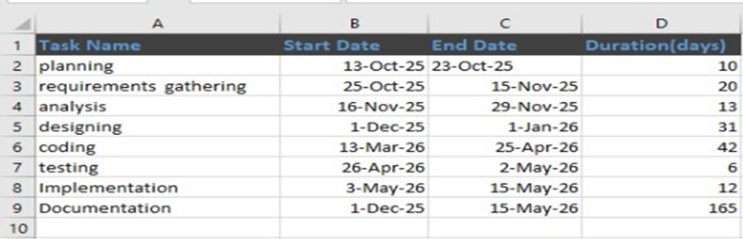
Figure 1 Project planning
1.12 Gantt Chart:
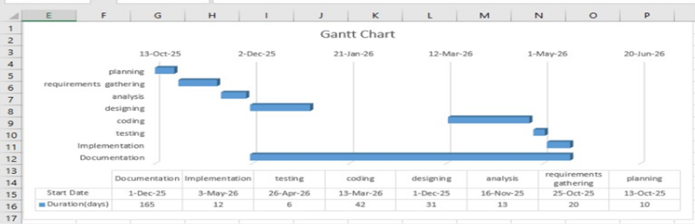
Figure 2 Gantt Chart

1.13. Summary
In this chapter we provider the overall introduction of the project about what problem we are going to solve and why the need for this system arises. Through problem statements we highlighted the issue of finding reliable service history tracking, and inefficient booking methods in local service markets. Later, we explain the solution in the form of a service booking and management system were customer and service providers can use their respective dashboards to manage bookings, track service status, and maintain history.
Then we listed the specific, measurable, and realistic objectives that define the goal of the system. In the scope section we clearly define the boundaries, stakeholders, and key features of the project. We explained the different modules such as customer panel, service provider panel, and admin panel in system components. Through market analysis and vision statements we examined how this system is better than other existing ones like TaskRabbit or urban company, and what are the long term goals. Summary of this chapter shows how the base structure of this system is designed so that it brings ease in real world local service markets and the system should be effective.This chapter performs a strong foundation to achieve the objectives of the system.

Chapter 2

Requirements Analysis

2. Analysis
In this chapter ,we analysis the software Requirements Specification (SRS) for the Servista web application describes the functional, non-functional, user, and system requirements of Servista, a web based platform that connects customer with service providers offering a wide range of services such as home maintenance, cleaning, painting, repairs and professional support. This analysis ensures that the system satisfies the needs of different user, including customers, service providers, and administrators. It details the objectives, scope, interested parties, functional module system architecture, limitations and security considerations. The document serves as a plan for developers, ensuring that the system meets the user’s needs while maintaining scalability, performance and data safety. Through well-defined requirements, the SRS guarantees that servista delivers a safe, easy to use and safe services experience.

2.1. User classes and characteristics
User Class | Characteristics
Customers | Users who book services and need a simple, fast, and reliable platform to find trusted service providers.
Service Providers | Skilled professionals who use the platform to receive job requests, manage schedules, and earn income.
Administrators | Staff responsible for managing users, monitoring service quality, resolving issues, and maintaining system operations.
Table 5 User classes and characteristics

2.2. Requirement Identifying Technique
In identifying the functional requirements for Servista, the use case technique is applied because servista is an interactive web-based home service platform. This technique allows defining interactions among customers, service, providers and administrators for efficient system operation. The system is designed at another level of detail for each service function. Every functionality is simplified in a way that captures the main user actions with the expected system actions in return. These interrelations are captured in separate use case diagrams and are described in full dressed use cases. These are some of the most important use cases and their corresponding requirements:
Use case Name and Associated Requirements
Use case name | Associated Functional Requirements
User Registration | Users must be able to register by providing personal details such a name, phone number, and address.
Service Booking | Customers should be able to book a service from available categories (plumbing, electrical, and cleaning, etc.).
Service Provider availability | Service providers should be able to update their availability and working schedule in the system.
Service Tracking | Customers should be able to track the status of their booked service in real time.
Payment processing | The system must allow users to make secure payments via online gateways or cash-on-delivery options.
Service history | Users should have access to their previous services records for reference or rebooking.
Provider Assignment | The system should automatically assign available and nearby service providers to customers.
Rating and Reviews | Customers should be able to submit feedback after service completion.
Table 6 Use case Name and Associated Requirements

2.2.1. Use Case Diagram

- Customer use case diagram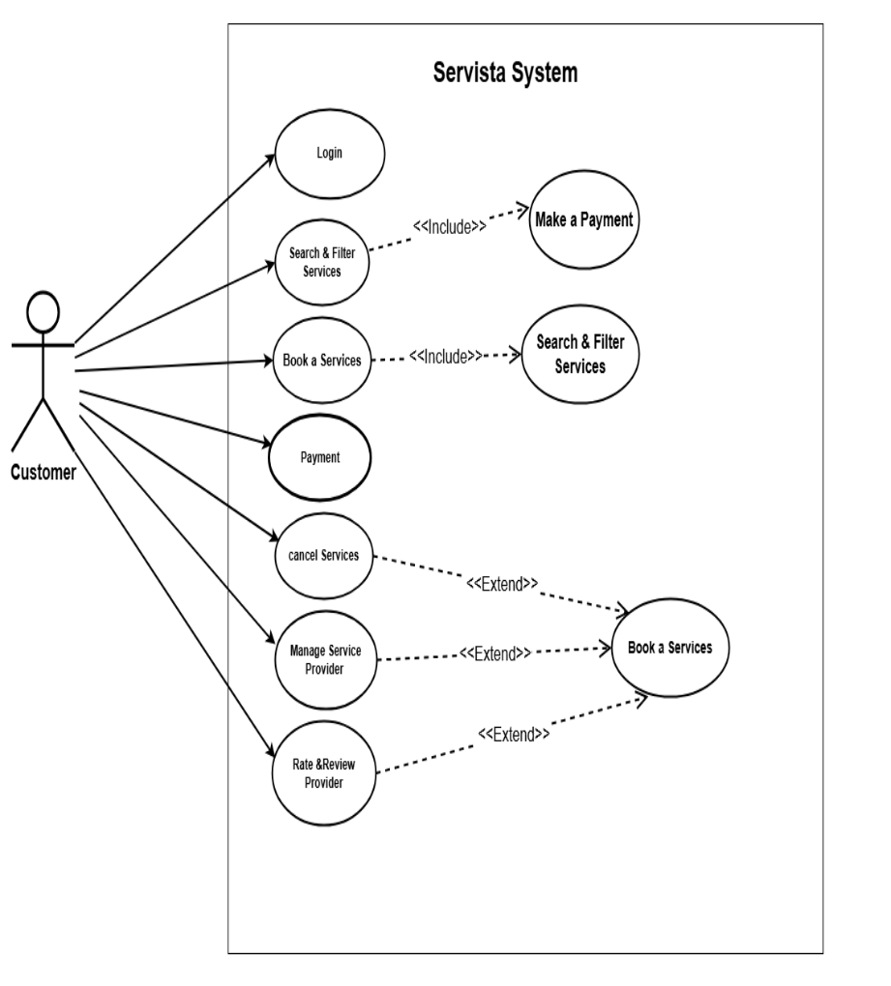
Figure 3 Customer use case diagram

- Service providers use case Diagram:
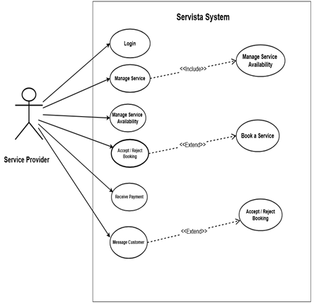
Figure 4 Service providers use case Diagram

- Admin use case Diagram
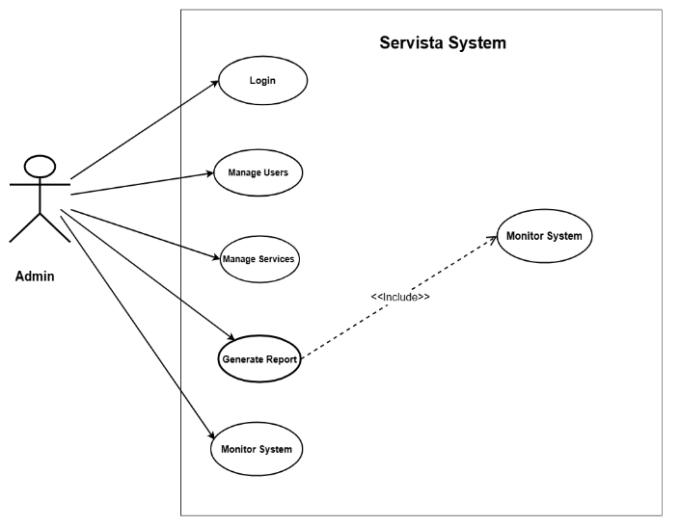
Figure 5 Admin use case Diagram

2.2.1.1. Use Case # 1: User Registration and Authentication
UC Identifier | UC1: Register and Authenticate User
Requirement Traceability | FR-1(User Registration and Authentication)
Purpose | To allow customers, service providers, and administrators to securely register and log in to the servista platform
Priority | High
Preconditions | The user has access to a valid email /phone number and the Servista login/registration interface.
Postconditions | The user is successfully authenticated and redirected to their respective dashboard (customer, provider, admin).
Actors | Customer, Service Provider, Administrator
Extends | None
Main Success Scenario | 1. User enters registration details.  2. System validates inputs.  3. User receives OTP /email verification.  4.User log in  5. System grants access to the dashboard.
Table 7 Use Case # 1: User Registration and Authentication

2.2.2 Use Case #2: Search and Filter Services
UC Identifier | UC2: Search and Filter Services
Requirements Traceability | FR-2(Service Browsing and Filtering)
Purpose | Allows customers to search for home services using filters such as category, price, availability, and location.
Priority | High
Preconditions | User is logged in or browsing as a guest; services are available in the system.
Postconditions | A list of services matching the user’s filters is displayed.
Actors | Customer
Extends | Browsing Services
Main Success Scenario | 1. User opens search page  2. Selects filters (e.g., category, location, price)  3. System retrieves matching services  4. User views services list.
Table 8 Use Case #2: Search and Filter Services

2.2.3. Use Case #3: Book a Service
UC Identifier | UC3: Book a Services
Requirements Traceability | FR –3(Service booking)
Purpose | Allows customers to schedule and book a service with a selected service provider.
Priority | High
Preconditions | User is logged in; service provider has an available time slot.
Postconditions | Booking is saved, and confirmation is sent to both customer and provider.
Actors | Customer, Service provider
Extends | Search and Filter Services
Main Success Scenario | 1. Users select provider.  2. chooses date/time.  3. Enters address.  4. Confirms.  5. Payment completed.  6. Booking confirmed.
Table 9 Use Case #3: Book a Service

2.2.4 Use Case #4: Manage Service Availability
UC Identifier | UC4: Manage Services Availability
Requirements Traceability | FR –4(Provider Availability Management)
Purpose | Allows service providers to update their working hours, available dates, and prices.
Priority | Medium
Preconditions | Provider is logged into their account.
Postconditions | Updated availability is reflected in customer search results.
Actors | Service provider
Extends | None
Main Success Scenario | 1. provider opens  2.availability page.  3. Edits schedule.  4. Saves changes.  5. System updates.  6. Availability calendar.
Table 10 Use Case #4: Manage Service Availability

2.2.5 Use Case #5: Payment and Confirmation
UC Identifier | UC5: Payment and Confirmation
Requirements Traceability | FR –5(Payment processing)
Purpose | Allows customers to pay securely and receive booking confirmation.
Priority | High
Preconditions | User has selected a service and confirmed booking details.
Postconditions | Payment receipt generated; booking marked as confirmed.
Actors | Customer, Payment gateway
Extends | Book a Service
Main Success Scenario | 1. User selects payment method.  2.System processes payment.  3. Payment succeeds.  4. Confirmation sent.
Table 11 Use Case #5: Payment and Confirmation

2.3. Functional Requirements
Functional requirements define how the servista system should operate and the actions it must support for customers, service providers, and administrators.

2.3.1. Functional Requirement FR-1: User Registration and authentication
Identifier | FR-1
Title | User Registration and authentication
Requirement | The customer, service provider, or administrator shall be able to create an account, log in, and manage authentication securely using an email /phone number and password. Service providers shall also be able to upload identification documents for verification.
Source | System requirement
Rationale | Required for secure access control, user identity verification, and personalized services experience on the servista platform.
Business Rule | User credentials must be encrypted and comply with security standards. Duplicate emails/phone numbers shall not be allowed. Servista providers must upload valid documents for verification.
Dependencies | Required for service browsing and search (FR-2), service booking (FR-3), and provider assignment (FR-4).
Priority | High
Table 12 Functional Requirement FR-1: User Registration and authentication

2.3.2. Functional Requirement FR-2: Service browsing and search
Identifier | FR-2
Title | Service browsing and search
Requirement | The customer shall be able to view available service categories (plumbing, cleaning, electrical, and solar installing etc.) and search for specific services based on location, category, or keywords.
Source | User requirement
Rationale | Enable customers to quickly find appropriate services and make informed decisions.
Dependencies | Requires user profile (FR-1) and service database setup.
Priority | High
Table 13 Functional Requirement FR-2: Service browsing and search

2.3.3. Functional Requirement FR-3: Service Booking
Identifier | FR-3
Title | Service Booking
Requirement | The customer shall be able to book a service by selecting a provider, data, time, and service location. The system shall confirm availability before completing the booking.
Source | Core user requirement for service request and scheduling.
Rationale | Provides the main purpose of the platform –scheduling home services.
Dependencies | Depends on provider availability (FR-4) and user registration (FR-1).
Business rule | Booking may not be created without verified user information. Double booking the same provider at the same time is not allowed.
Priority | High
Table 14 Functional Requirement FR-3: Service Booking

2.3.4. Functional Requirements FR-4: Provider Availability Management
Identifier | FR-
Title | Provider Availability Management
Requirement | Service providers shall be able to update their availability (dates, time slots) so that the system can assign them to customer bookings accordingly.
Source | Operational requirement for coordinating service assignments.
Rationale | Ensures accurate scheduling and prevents conflicts or double bookings.
Business rule | Providers must maintain up-to-date availability to remain eligible for booking.
Dependencies | Required for services booking (FR-3) and provider assignment processes.
Priority | Medium -High
Priority | High
Table 15 Functional Requirements FR-4: Provider Availability Management

2.3.5. Functional Requirements FR-5: Real time Service Tracking
Identifier | FR-5
Title | Real time Service Tracking
Requirement | The customer shall be able to track the status of their booked service in real-time (e.g., Accepted, on the way, in progress, completed). Providers shall update their status from their interface.
Source | User requirement for transparency and service monitoring.
Rationale | Enhances customer trust and provides visibility into the progress of the service request.
Dependencies | Depends on service booking (FR-3) and provider profiles (FR-1).
Business rule | Status updates must be accurate; providers must update status at each stage.
Priority | Medium 2
Table 16 Functional Requirements FR-5: Real time Service Tracking

2.3.6. Functional Requirements FR-6: Secure Payment Processing
Identifier | FR-6
Title | Secure Payment Processing
Requirement | The system shall allow customers to make payments using multiple methods such as credit/debit cards, mobile wallets, or cash on delivery. The system shall validate and confirm payment before booking completion.
Source | Business requirement for payment verification and service charges.
Rationale | Enables revenue processing and ensures secure financial transactions.
Dependencies | Requires service booking (FR-3) and user registration (FR-1)
Business rule | Payments must use encrypted channels; unauthorized transactions must be flagged or rejected.
Priority | High
Table 17 Functional Requirements FR-6: Secure Payment Processing

2.3.7. Functional Requirements FR-7: Ratings and Reviews System
Identifier | FR-7
Title | Ratings and Reviews System
Requirement | The customer shall be able to rate service providers and write reviews after a service is completed. The system shall store this feedback and display average ratings on provider profiles.
Source | User experience requirement to evaluate service quality.
Rationale | Helps maintain service quality and assists users in choosing reliable providers.
Dependencies | Depends on completed service status (FR-5).
Business rule | Reviews can only be submitted after service completion; inappropriate content may be removed by admin.
Priority | Medium
Table 18 Functional Requirements FR-7: Ratings and Reviews System

2.3.8. Functional Requirements FR-8: Admin Management Dashboard
Identifier | FR-8
Title | Admin Management Dashboard
Requirement | The administrator shall be able to manage users, service providers, service categories, complaints, and system data using an admin dashboard.
Source | Business requirement for system maintenance and oversight
Rationale | Ensures the smooth operation of the platform and maintains data integrity.
Dependencies | Depends on user registration (FR-1), service categories, and booking data.
Business rule | Only authorized admins can access the dashboard; admin actions must be logged for security.
Priority | High
Table 19 Functional Requirements FR-8: Admin Management Dashboard

2.3.9. Functional Requirements FR-9: Notification system
Identifier | FR-9
Title | Notification system
Requirement | The system shall send notifications to customers and service providers regarding booking confirmations, cancellations, service status updates, and payment confirmations.
Source | User requirement for timely updates and communications
Rationale | Ensures users are informed about important events, improving service coordination.
Dependencies | Depends on service booking (FR-3), payment processing (FR-6), and service tracking (FR-5).
Business rule | Notifications must be triggered in real time and must match system events accurately.
Priority | Medium -High
Table 20 Functional Requirements FR-9: Notification system

2.3.10. Functional Requirements FR-10: Service History Management
Identifier | FR-10
Title | Service History Management
Requirement | The system shall store and display past service records both customers and service providers, including completed bookings, payments, and reviews.
Source | User requirement for record -keeping and reference.
Rationale | Helps users review past services and assists providers with performance tracking.
Dependencies | Depends on service completion updates (FR-5) and payment records (FR- 6).
Business rule | Records must not be deleted unless required by legal or data policy rules.
Priority | Medium
Table 21 Functional Requirements FR-10: Service History Management

2.4. Non-Functional Requirements
Non-functional requirements define how the system should behave and specify the performance, security, reliability, usability, scalability, and other quality standards a system must meet.
They do not define system features; instead, they define the constraints and behavioural qualities of those features.

2.4.1 Performance Requirements
• The system should load any page within 2-3 seconds.
• Response time should not exceed 5 seconds during high traffic.

2.4.2 Security Requirements
• User passwords must be encrypted.
• Only authorized users can access admin functions.
• The system must comply with data protection laws.

2.4.3 Usability Requirements
• The interface must be simple and easy to navigate.
• Users should be able to complete registration in under 2 minutes.

2.4.4 Reliability Requirements
• The system should have 99.5% uptime.
• The platform must recover automatically from minor errors.

2.4.5 Scalability Requirements
• The system must handle increasing users without performance degradation.
• Support up to 50,000 concurrent users.

2.4.6 Maintainability Requirements
• The system should allow developers to update modules without downtime.
• Code must follow standard naming conventions.

2.4.7 Availability Requirements
• The service should be available 24/7.
• Downtime for maintenance should not exceed 2 hours per month.

2.4.8 Compatibility Requirements
• Works on all major browsers (Chrome, Safari, Firefox, Edge).
• Supports web + mobile responsiveness.

Chapter 3

Design and Architecture

3.1 System Design
The Servista Web Application is designed as a centralized digital platform that connects customers with trusted professionals for tasks like repairing, electrical work, carpentry, cleaning, and many more. The system work as an application based on the web that interact with multiple external services and API’s which allow perfect integration with location services, real time booking notifications, secure payment gateway and vender verification system, enhancing the overall user experience.
The application follows a modular architecture, ensuring flexibility, maintenance ease, and more. Following are the central component of this Web Application:
  - Frontend (User Interface):
Developed with React.js, to provide the responsive user interface for Customers, Service Providers, and Administrators.
  - Backend (Server Layer):
Built with Node.js and Express.js, managing Authentication, Service listing, Job requests and scheduling, and In-app messaging.
  - Database Management:
Use MongoDB for structured data storage (user profiles, services record, job orders, and customers reviews).
  - Third party Integrations:
    - Payment Gateways-secure transaction between customer bank card to your service provider.
    - Service scheduling platform-it prevents double booking and matches job with skilled professionals.
    - Customer Engagement Platform store and manage booking history, customer data and communication records in one place.
Dependencies and Interactions:
• The system depends on a stable internet connection.
• Frontend (React) interacts with the backend (Node.js) through API calls.
• Backend connects to MongoDB to fetch and store data.
Design Constraints:
• The system should be able to handle 100+ users at the same time without crashing.
• Response time should be less than 2 seconds for any major action (like booking, loading queue).
• The chatbot is text-only and does not support voice.
• The system must run on standard desktop and mobile browsers.
• No multi-clinic or multi-branch support in this version.
• System must be completed within the final year timeline with limited team and resources.

3.2 Design Considerations:
- Assumptions and Dependencies:
Assumptions | - Trusted service hub  - Seamless online booking and payment  - Growing demand for home services online  - Rising trust in online payment
Dependencies | - Reliable professional  - Communication dependency  - Financial dependency
Table 22 Assumptions and Dependencies
2. Limitations:
Performance | - Database overload  - Scalability bottleneck  - Real time update
Functional | - Scheduling limitations  - Service package limitations  - Location based services  - Payment process limitation
Table 23 Limitations

3.3 Design Models:
Servista web application follows an object-oriented development approach, which incorporates several design models to illustrate the structure, behavior, and system interactions. The key models used to describe the system design are presented below:

3.3.1 Design Class Diagram (DCD):
- UML Class Diagram
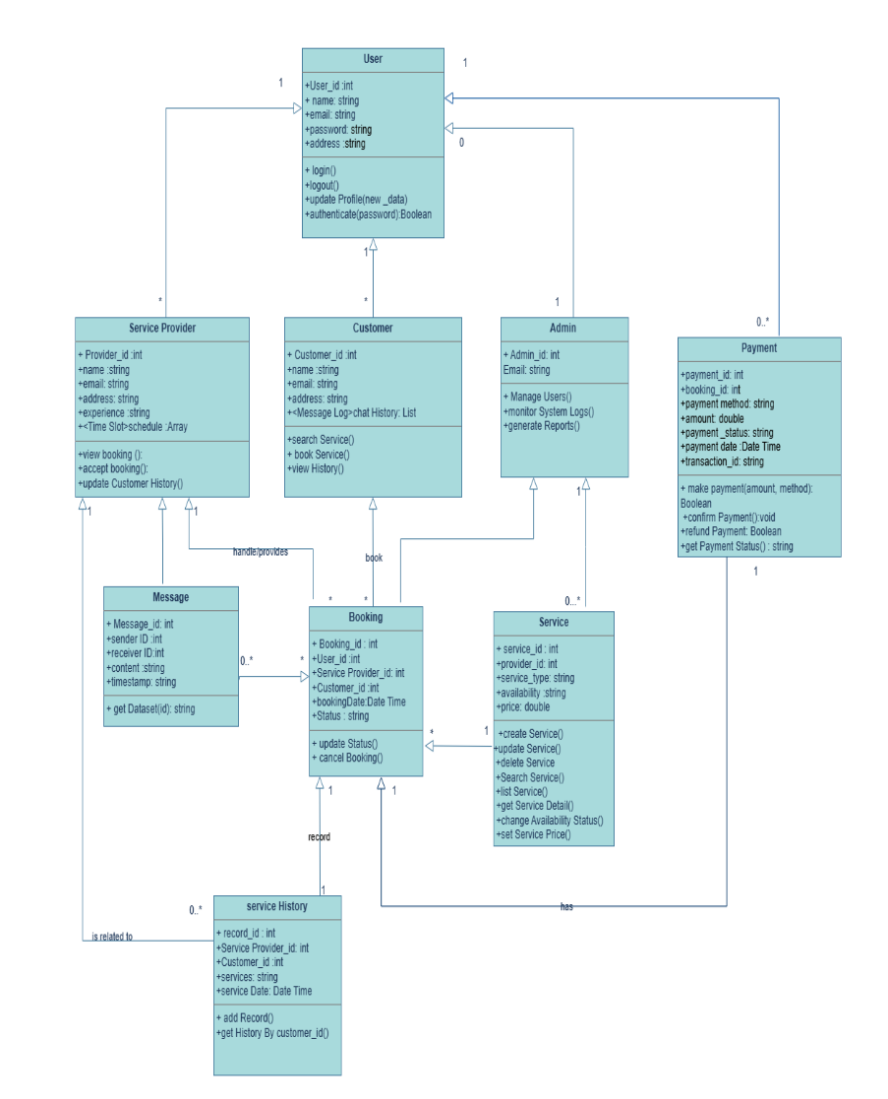
Figure 6 UML Class Diagram

3.3.2. Sequence Diagram:
1.User Authentication Sequence Diagram
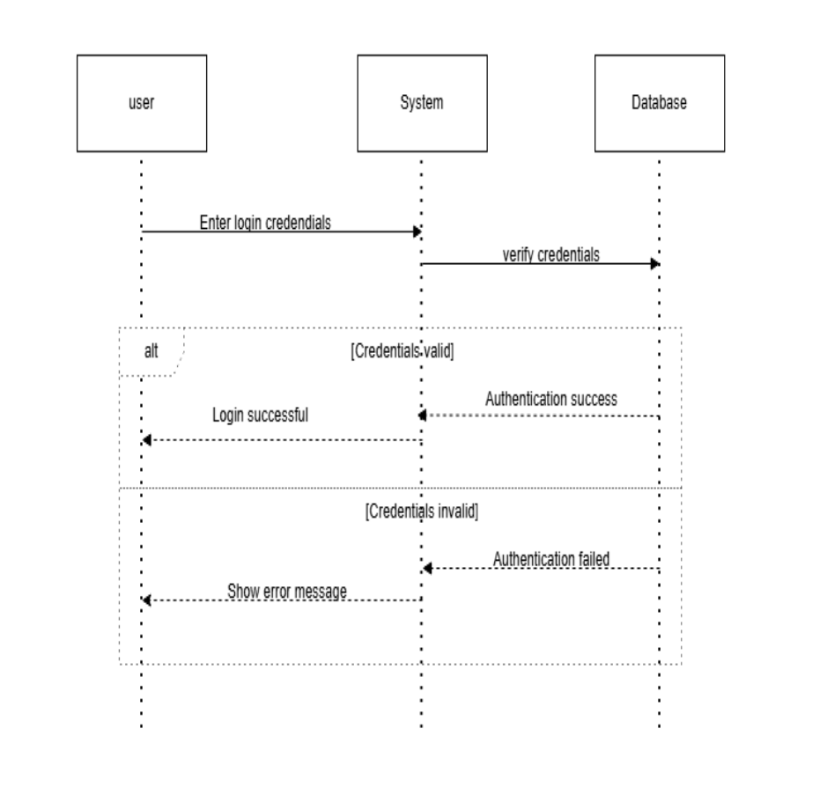
Figure 7 User Authentication Sequence Diagram

2.Service Search Sequence Diagram:
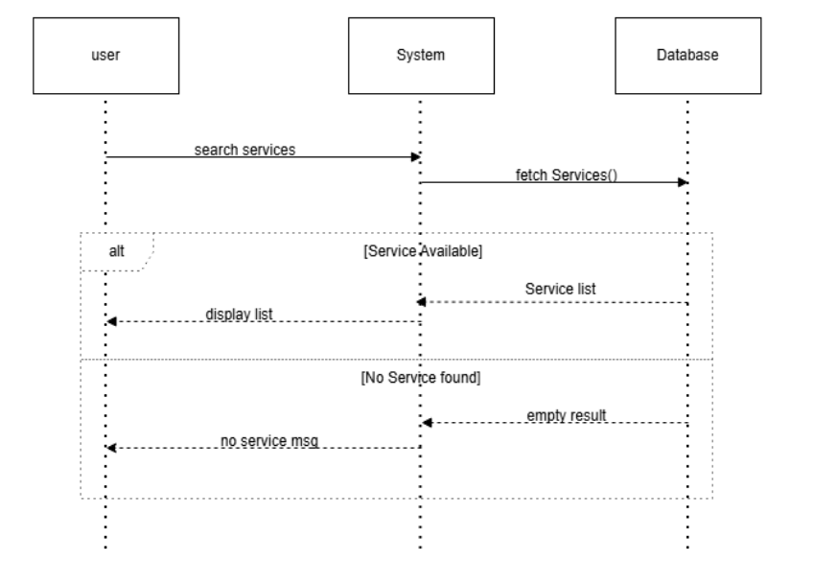
Figure 8 Service Search Sequence Diagram

3.Service Booking Sequence Diagram:
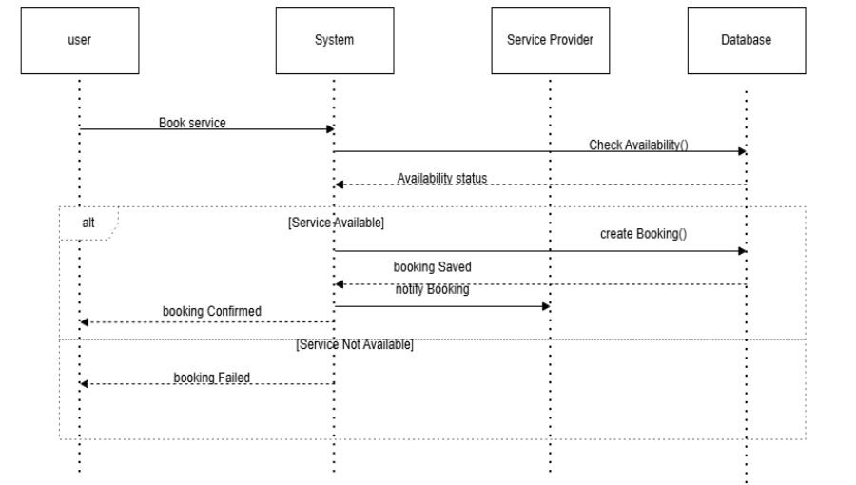
Figure 9 Service Booking Sequence Diagram

4. Payment Processing Sequence Diagram:
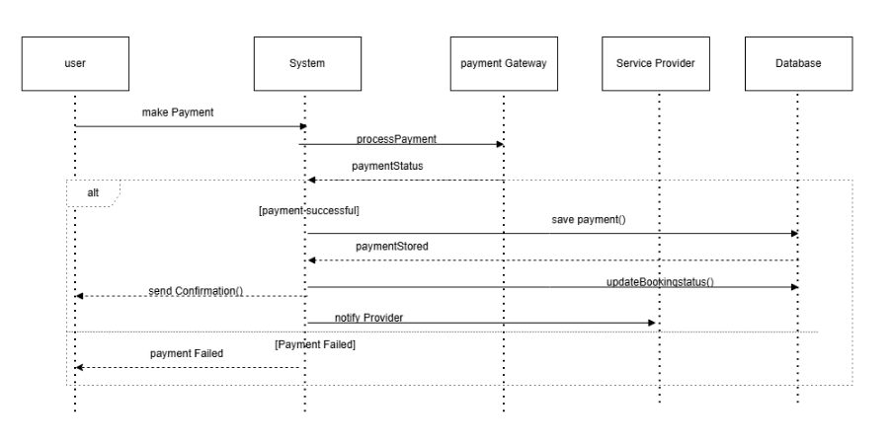
Figure 10 Payment Processing Sequence Diagram
5. Messaging Sequence Diagram:
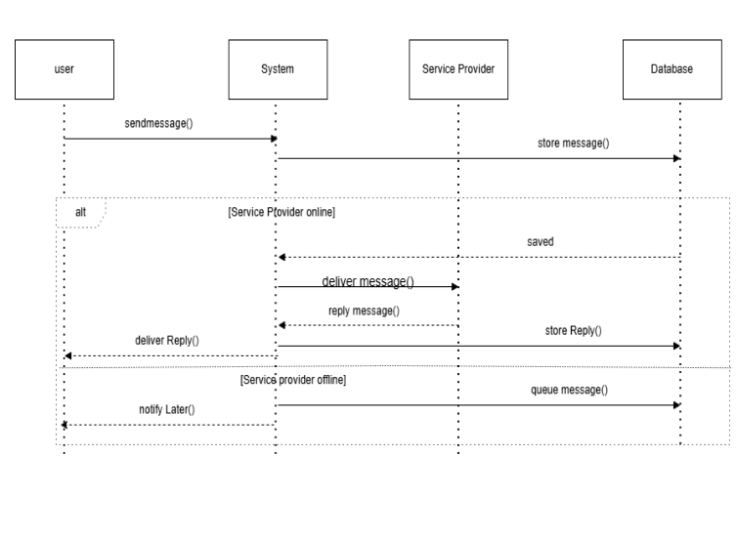
Figure 11 Messaging Sequence Diagram

6. Service Completion & History Sequence Diagram:
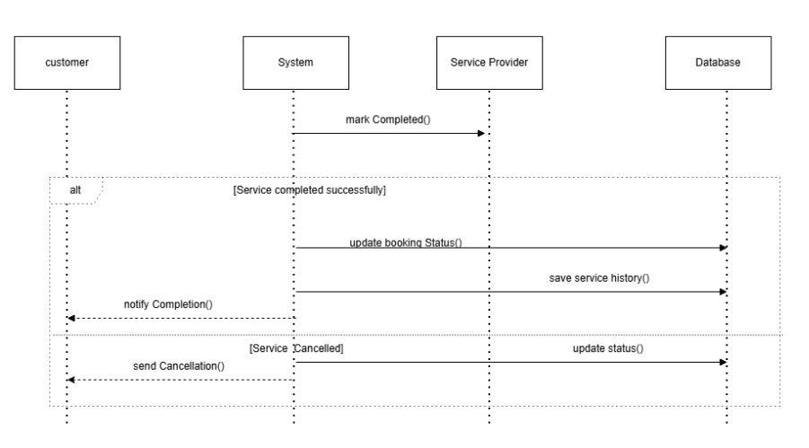
Figure 12 Service Completion & History Sequence Diagram

3.3.3 State Transition Diagram:
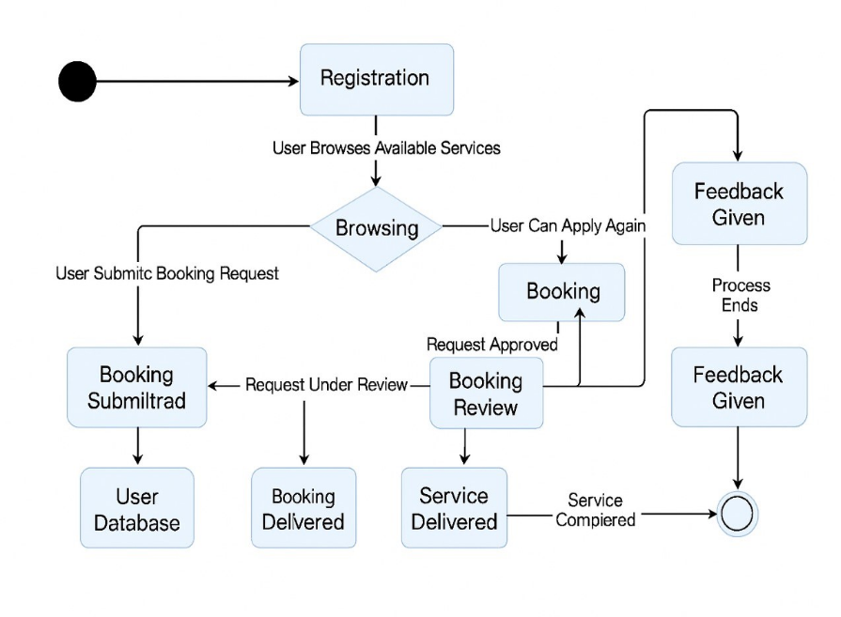
Figure 13 State Transition Diagram

3.4 Architectural Design:
Our system follows the MVC (Model-View-Controller) architecture using the MERN stack. It is a web based client-server model where the frontend (React) communicates with the backend (Node.js + Express), and the backend interacts with the database (MongoDB).
Main Components:
1. Model:
- Manages data and database operations.
- Includes user data, bookings and service records.
2. View:
- The React-based user interface seen by customer and service provider.
- Displays forms, dashboards and chatbot interface.
3. Controller:
- Handles user requests and connects the view with the model.
- Includes API routes and backend logic written in Node.js.
Component Relationships:
• Frontend (React) sends API requests to the backend
• Backend (Node + Express) processes requests and accesses MongoDB
• Database (MongoDB) stores all data like users, booking and chat history
• Chatbot logic is handled in the backend with a rule based system.

UML Component Diagram:
Displays how the frontend, backend, and database interact. Each major function (login, booking, chatbot) is shown as a component connected to others.
Block Diagram
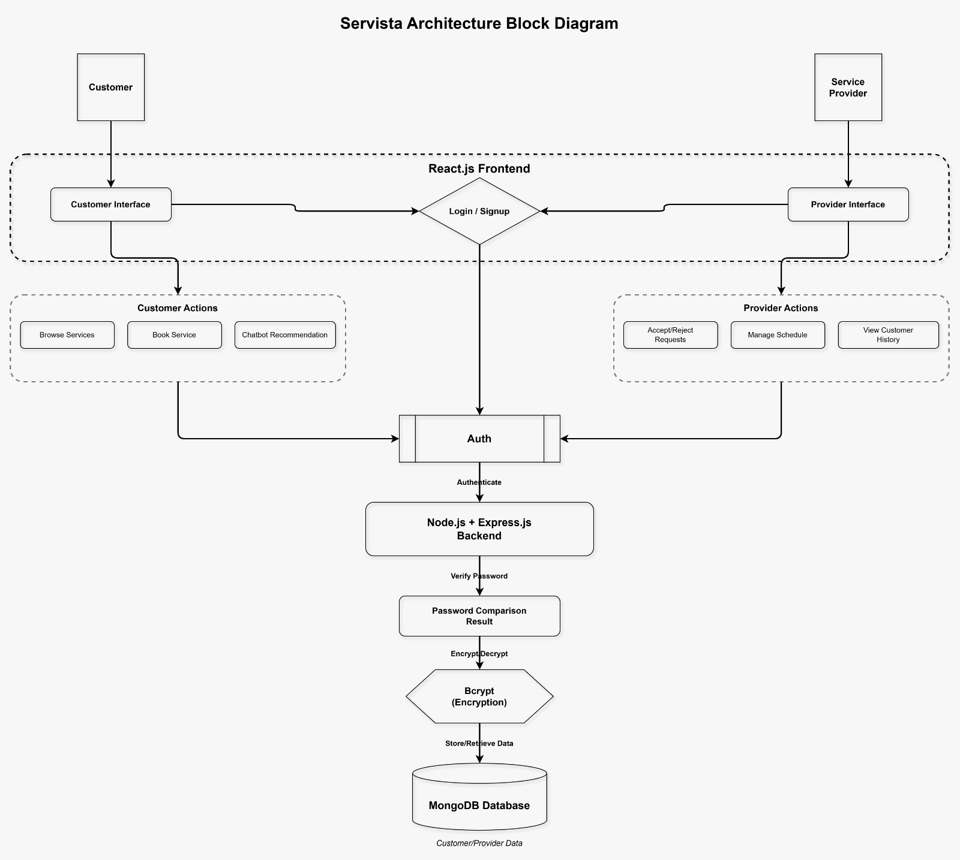
Figure 14 Block Diagram

Database Diagram
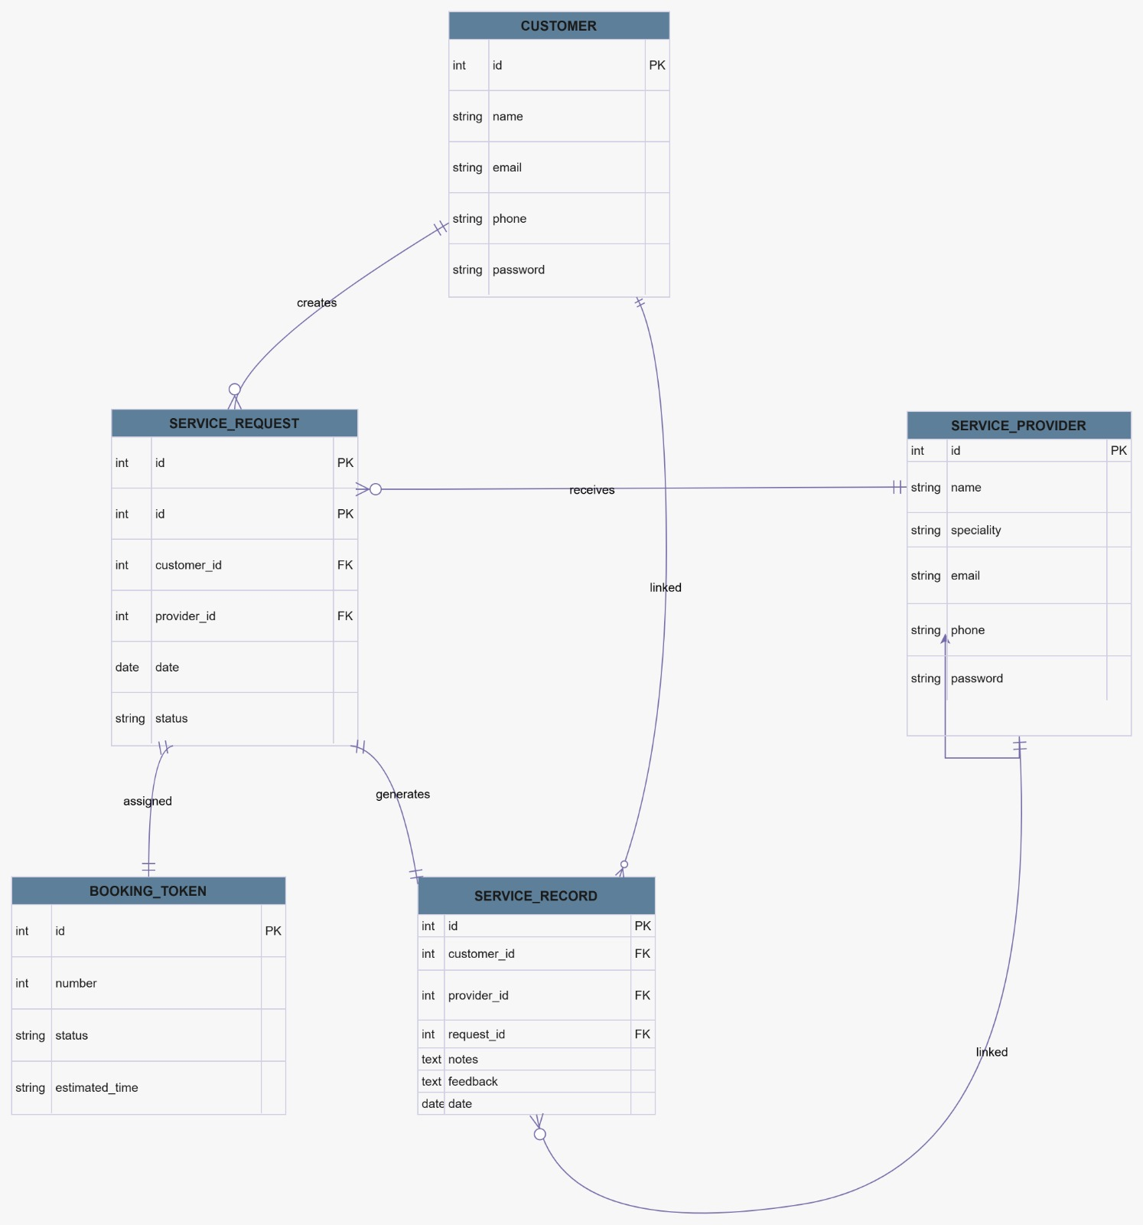
Figure 15 Database Diagram

Deployment Diagram
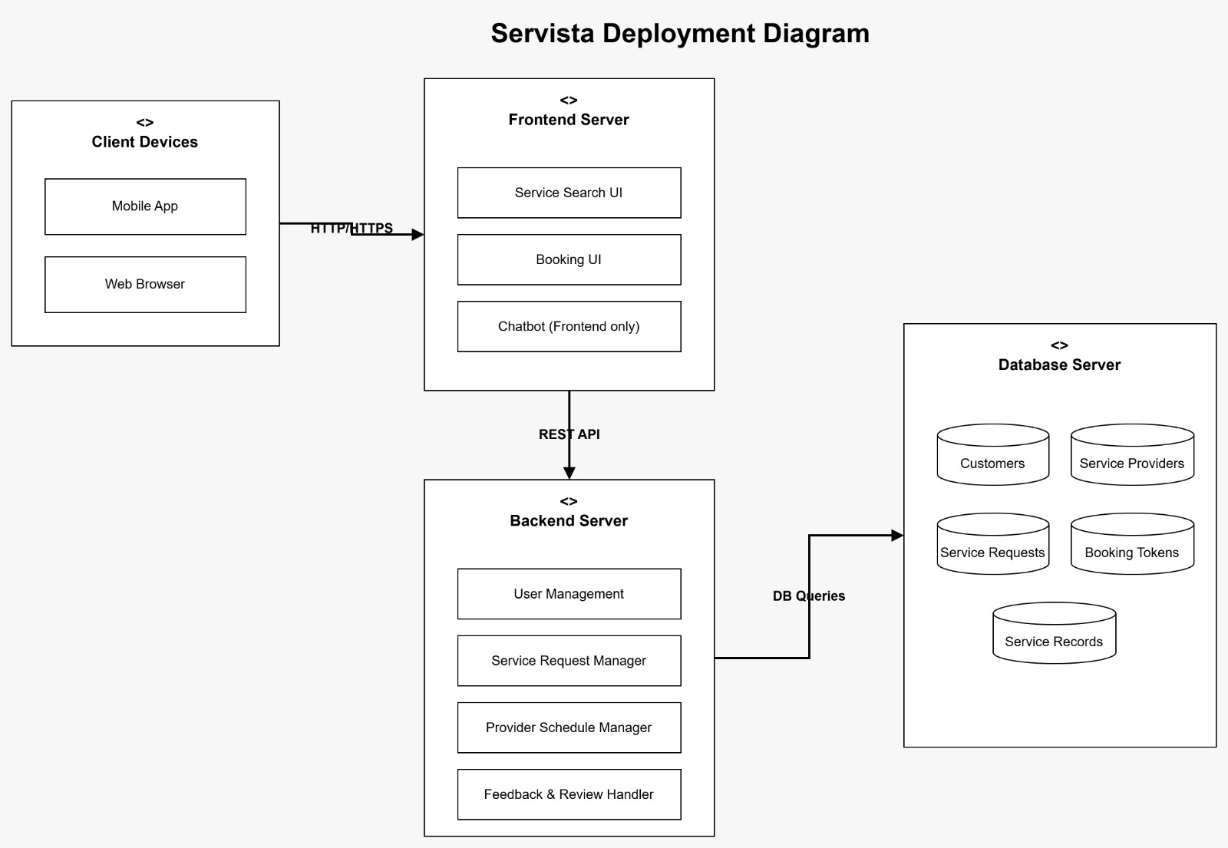
Figure 16 Deployment Diagram

3.5 Data Design
The system uses MongoDB as the database to store and manage all data. MongoDB is a NoSQL database, which stores data in the form of collections and documents (JSON format).
Data is stored in flexible, JSON like documents within collections, allowing easy integration within collections, allowing easy integration with the Node.js/Express backend and React Frontend.
Each major part of the system has its own collection to keep data organized and easy to access.
Main Collections (Entities):
1.Users Collection:
- Stores user details (name, email, phone number, address)
- Stores login credentials (hashed password, role: customer/service provider /admin)
- Support authentication and profile management
2.Services Collection:
- Stores services information (title, description, category, base price, estimated duration)
- Includes service provider references and availability flags
- Support search, filtering, and categorization
3.Bookings Collection:
- Stores booking details (customer id, service id, provider id, booking date/time)
- Includes status (pending, confirmed, in progress, completed, cancelled)
- Stores special requests, total price, and payment status
    - Providers Collection:
- Store service provider profiles (business name, contact info, service area)
- Includes working hours, ratings, verification status
- Links to the services they offer
    - Reviews and ratings Collection:
- Stores feedback from customers after service completion
- Includes rating (1-5), review text, and timestamps
- Linked to booking ID, customer ID, and provide ID
    - Payments Collection:
- Stores transaction details (amount, method, status, transaction ID)
- Links to a specific booking
- Supports payment history and invoice generation
How data is used:
- When a user signs up or logs in, credentials are verified against the user's collection, and JWT token is generated for authenticated sessions.
- When a customer searches for services, data is fetched from the services collection, filtered by category, price, or provider.
- On booking a service, data is added to the bookings collection, and the service status is updated to “pending or confirmed”.
- After service completion, the provider marks the booking as completed, which triggers:
- A payment record is created in the payments collection.
- The customer can add a review, which is stored in the reviews collection.
- Providers can view their assigned bookings, update availability, and manage services through the services and bookings collections.
- Admins can monitor all users, bookings, and payments, and resolve disputes using data from all collections.

3.5.1. Data Dictionary
Purpose:
- To provide a clear and well organized list of all system objects, their attributes, and key data elements.
- Each item includes its data type and a short description of its purpose in the system.

Format:
- Object Name: Description of the object’s role.
- Attributes: All attributes with data types and short descriptions.
- Methods: All related methods with parameters and their purpose.
Object: User
Description:
Handles authentication and profile management for all system users (customers, service providers, admins).
Attributes:
- User id (string): unique id for the user.
- Name (string): Full name of the user.
- Email(string): Email address (used for login).
- Password (string): hashed password.
- Phone (string): Contact number.
- Address(string): Physical address.
- Role(string): User type (customer, provider, admin).
- Create At (Date): Account creation timestamp.
Methods:
- Register (name, email, password, role) →Creates a new user account.
- login (email, password) →Authenticates user and returns a JWT token.
- get Profile (user ID) →Retrieves user details.
Object: Service
Description:
Stores information about services offered by providers.
Attributes:
- Service id (string): Unique ID for the service.
- Title (string): Name of the service description.
- Description(string): Detailed service description.
- Category (string): Service category (e.g., cleaning, plumbing, IT).
- Base Price (Number): Starting price for the service.
- Estimate Duration(string): Expected time to complete (e.g., 2 hours).
- Provider ID (string):ID of the service provider offering this service.
- Is Available (Boolean): Whether the service is currently bookable.

Methods:
- add service (provider ID, title, description, price) →Adds a new service.
- get service By Category(category)→returns all services in a category.
- update Service (service Id, updates) →modifies service details.
Object: Booking
Description:
Handles booking details between a customer and a service provider.
Attributes:
- Booking ID (string): Unique ID for the booking.
- Customer ID (string):ID of the customer.
- Provider ID (string):ID of the service provider.
- Service ID (string):ID of the booked service.
- Booking Date (Date): Date when the booking was made.
- schedule Date (Date): Date of service delivery.
- schedule Time (String): Time of service delivery.
- status(string): status (pending, confirmed, in-progress, completed, cancelled).
- total Price (Number): Final price after any adjustments.
- Special Requests (String): Any customer notes.
Methods:
- Create Booking (customer ID, service ID, schedule Date, time) → Creates a new booking.
- cancel Booking (booking ID) →Updates status to cancel.
- Get Bookings by Customer (customer ID) →Returns all bookings for a customer.
- Update Booking Status (booking ID, status) →Changes booking status.
Object: Review
Description:
Stores customer feedback and ratings for completed services.
Attributes:
- Review ID (string): Unique ID for the review.
- Booking ID (string): ID of the completed booking.
- Customer ID (string):ID of the customer writing the review.
- Provider ID (string):ID of the service provider being reviewed.
- rating(number): Date when the booking was made.
- comment(string): Written feedback.
- Create At (Date): Timestamp of review submission.
Methods:
- add Review (booking ID, rating, comment) → Creates a new review.
- Get provide Rating (provider ID) →Calculates average rating for a provider.
- Get Review by Provider (provider ID) →Returns all reviews for a provider.
Object: Payment
Description:
Handles transaction details for bookings.
Attributes:
- Payment ID (string): Unique ID for the payment.
- Booking ID (string): ID of the associated booking.
- amount(number): payment amount.
- method(string): payment method (credit card, cash, wallet).
- Status(string): payment status (pending, completed, failed, refunded).
- Transaction ID (string): gateway transaction reference.
- Payment Date (Date): Timestamp of payment completion.
Methods:
- process payment (booking ID, amount, method) → initiates payment.
- Get payment Status (payment ID) →Returns current payment status.
- refund payment (payment ID) →Processes a refund for cancelled bookings.

3.6. User Interface Design
The Servista web application is designed to be easy to use, intuitive and accessible to users who seek many different services at the same time, communicate with professionals and book them for services. The interface guarantees a perfect user experience with clear navigation, feedback messages, and interactive elements.
General Description of the User Interface:
The system is divided into three main user roles:
- Administrator: Supervises users, services and system configuration.
- Customers: User seeking the services that they need.
- Professionals: Provide the user requires services.
Functionality and user interaction:
1.Home page (destination page)
- Outstanding samples, upcoming discount events.
- Provide login/registration buttons for new users and return them.
- Search bar for required services.
2.User authentication (login/registration)
- Users can register by email/password or social networks.
- Comments: Successful messages or errors in sending the form.
3.Search and filtering Services
-When clicking on any service, it opens details about it.
4.Service booking page
-Show information about service i.e. discounts on the service, description.
-The “Request for Services” button for interested users.
-Comment: Confirmation message.
5.Messaging system
-Customers can communicate with Professional according to services directly.
- Input tray function for chat in real time.
-Comments: Message sent confirmation.
6.Pasure booking application process
- Users can see their booking requests sent.
-Review approved or reject applications.
-Comments: Users receive notifications about the status of the application.
7.Payment and review
-Check the online transaction that you have made.
-rate and review the professionals.
8.User dashboard
-View past services and booking and scheduled services.
-View update and notifications of services.

Screen images:
Sign in screen:
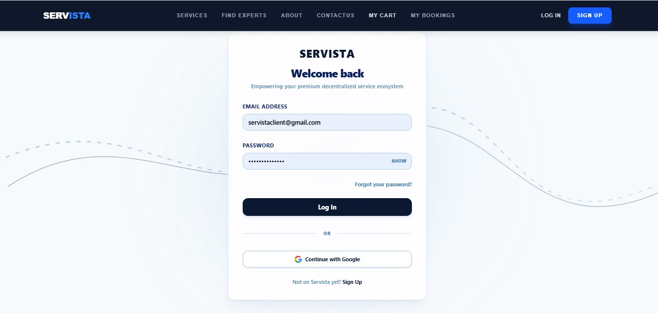 Figure 17 Sign in screen

Login screen:
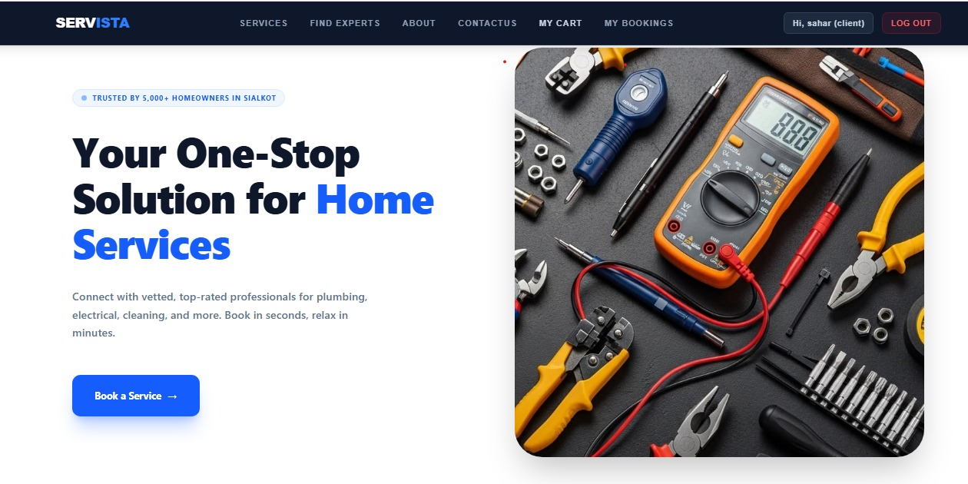

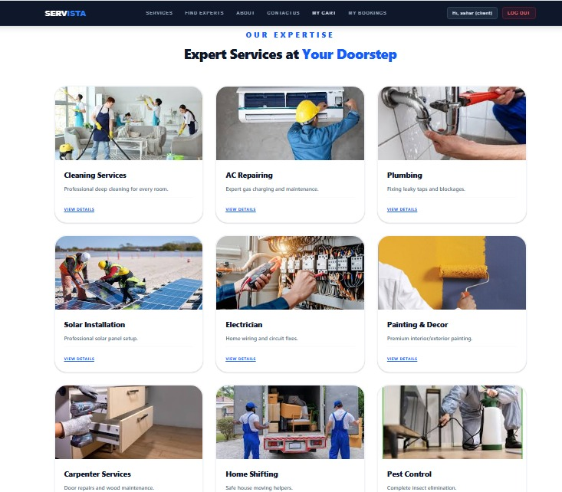
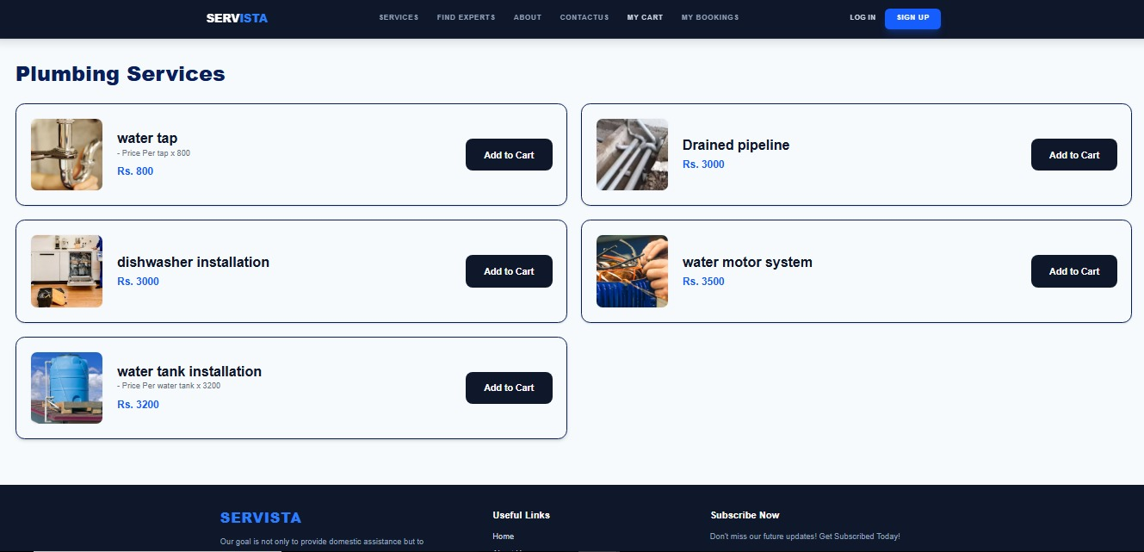

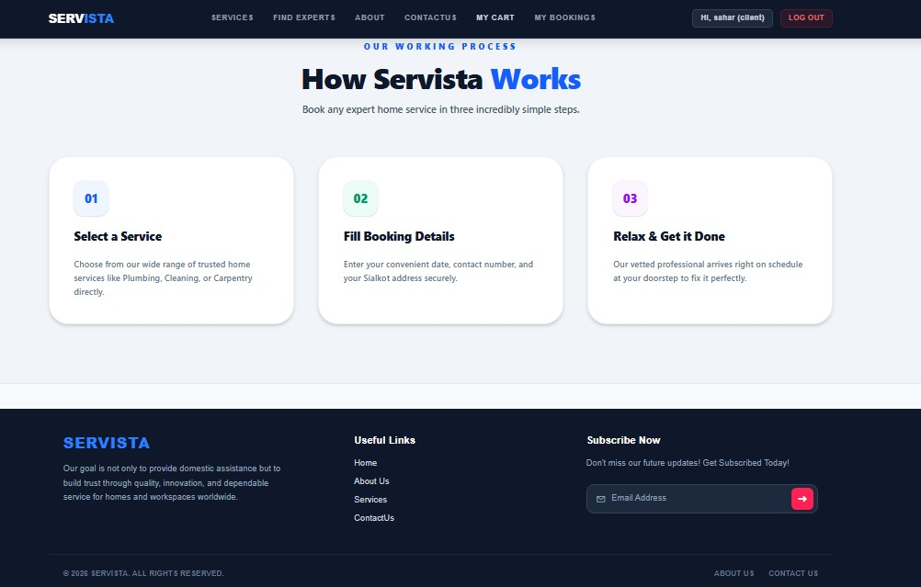
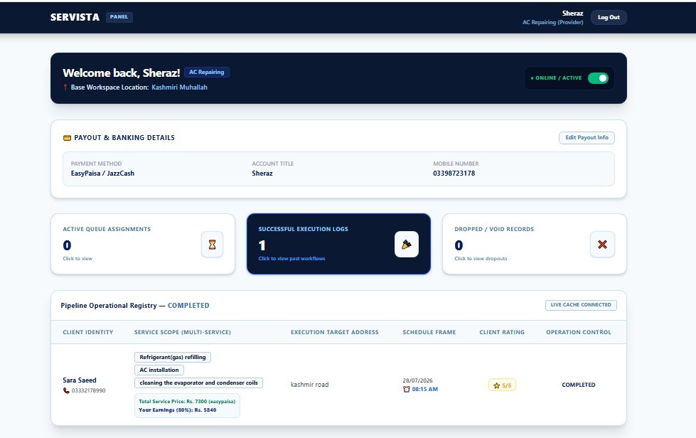
Figure 18 Login screens

3.6.1. Screen Objects and Actions
Use Case 1: book a Service (customer side)
Screen Object | Action Performed
Welcome Message | Greet customer name and show service dashboard overview.
Active Booking Section | Displays upcoming or ongoing service bookings.
Booking Status indicator | Shows number of active, completed, and cancelled bookings.
Recommended Services Section | Shows personalized service recommendations based on past bookings.
Service Card | Shows service title, provider name, price, estimation duration, and rating.
View Details Button | Opens full service details including description, provider info, and availability.
Book Now button | Initiates the booking process for the selected service.
Side Menu-Dashboard | Bring customers back to the main dashboard view.
Side Menu-Find Services | Navigates to service search and booking screen.
Side Menu-My Bookings | Opens customer’s booking history and upcoming appointments.
Side Menu-Payments | Shows payment history and pending transactions.
Side Menu-Profile | Opens customer profiles for editing personal details.
Slide Menu-logout | Logs the customer out of the system.
Table 24 Use Case 1: book a Service (customer side)
Use case 2: Manage Services (Provider Side)
Screen Object | Action Performed
Welcome Message | Displays personalized greetings with the provider’s business name.
Total Bookings Counter | Shows the total number of bookings received (today/week/all time.
Pending Counter | Shows number of pending service requests awaiting confirmation.
Completed Counter | Shows a number of successfully completed services.
Cancelled Counter | Shows the number of cancelled bookings.
Service Queue section | Lists upcoming service requests with customer name, scheduled date/time, and status.
Confirm booking button | Accepts a pending booking request.
Mark as completed button | Changes booking status to completed after service delivery.
Add new service button | Allows provider to add a new service offering (title, price, description)
Manage availability button | Updates working hours and service availability schedule.
Side Menu –reviews | Shows customer reviews and ratings received.
Side menu- earnings | Displays earnings summary and payment history.
Table 25 Use case 2: Manage Services (Provider Side)
Use case 3: Admin dashboard (Admin side)
Screen Object | Action Performed
Welcome Message | Displays admin name and system overview.
Total users counter | Shows total registered customers+ providers.
Total bookings counter | Shows system –wide total bookings.
Total Revenue Counter | Displays overall platform revenue.
Pending approvals counter | Shows number of new provider registers awaiting verification.
User management table | Lists all users with options to view, edit, suspend, or delete.
Verify provider button | Approves a newly registered service provider.
Booking management table | Lists all bookings with filtering status, date, or provider.
Dispute Resolution Section | Shows flagged bookings or customer complaints.
Generate report button | Exports system usage or revenue report (pdf/csv).
Side menu-manage categories | Add/ edits/deletes service categories.
Side menu-System Settings | Configures platform settings (commission rates, etc.)
Table 26 Use case 3: Admin dashboard (Admin side)

3.7. Design Decisions
While designing our system, we made the following key decisions to ensure simplicity, maintainability, and performance:

1. Object-Oriented Design Approach
We used the object-oriented (OO) design pattern because it helps in organizing code clearly using objects like User, Service, booking, payment, and review. This makes the system easier to manage, reuse, and extend in the future.
Key benefits for Servista:
Reusability: Core objects (e.g., User, Booking) can be reused across customer, provider, and admin modules.
Maintainability: Changes to one object (e.g., adding a discount field to booking) don’t break unrelated parts.
Scalability: New service types or user roles can be added by extending existing objects.

- MVC Architecture (MERN Stack)
We followed the MVC (Model –view-controller)
Pattern using MongoDB, Express.js, React.js, and Node.js.
- Model (MongoDB + Mongoose): Defines schemas for users, Services, Bookings, payments, and reviews. Handles all database interactions and business logic validations.
- View (React.js): Provides a dynamic, single page interface for customers, providers, and admins. Uses reusable components (Service card, Booking List, Dashboard Stats) and state management (Context API /Redux).
- Controller (Express.js +Node.js): Contains API route handlers that process requests, interact with models, and sed responses. Keep business logic separate from UI and database.
Why MVC for Servista:
- Separation of concerns: UI changes don’t affect database logic, and vice versa
- Faster development: Frontend and backend can be built in parallel.
- RESTful API ready: Controllers expose clean endpoints for React to consume via Axios/Fetch.

- Database Choice: MongoDB over SQL
We choose MongoDB (No SQL) instead of a relation database (SQL) for the following reasons:
Factor | MongoDB (Chosen)
Schema flexibility | Dynamic schemas –easy to add fields like special Requests or discount Code anytime
Data structure | Stores nested data naturally (e.g., booking contain service + customer details in one document)
Scalability | Horizontal scaling via sharding – ideal for growing user base
Development speed | JSON-like documents match JavaScript/Node.js ecosystem
For Servista specifically: service listings, bookings, and reviews have varying attributes (e.g., plumbing vs. cleaning services have different fields). MongoDB handles this without complex table redesigns.

- JWT-Based Authentication
We implemented JSON Web Token (JWT) authentication for secure, stateless user sessions.
- How it works: After logging in, the server issues a signed JWT. The react frontend stores it (HTTP Only cookie or local Storage) and sends it with every authenticated request.
- Why JWT: No server-side session storage needed, works seamlessly with scalable Node.js Backends, and supports role based access (customer, provider, admin).
- Role based Access Control (RBAC)
We designed three distinct user roles with specific permissions:
Role | Permissions
Customer | Browse services, book appointments, view booking history, add reviews, make payments
Provider | Manage own services, confirm /cancel bookings, update availability, view earnings and reviews
Admin | Approve providers, manage all users and bookings, resolve disputes, generate platform reports
Why RBAC: Prevents unauthorized access (e.g., a customer cannot modify provider earnings).
Each role sees only relevant UI components in react, and backend middleware verifies permissions on every API call.

- Real-Time updates (optional Enhancement)
For future scalability, we designed the system to support WebSocket (Socket.io) integration, enabling:
- Live booking status updates for providers
- Real time notifications for customers when a booking is confirmed
- Queue management for on demand services

3.8 Summary
This chapter explained how the servista system is designed to solve the main problems faced by customers and service providers in the service booking process. It covered the structure of the system, including how different modules (customer, provider, admin) work together and how the data is managed.
The diagrams helped us understand the flow of actions and relationships between components, such as:
- How a customer searches, books and pays for a service
- How a provider manages bookings and earnings
- How an admin oversees the entire platform
We also discussed the assumptions, risks, and limitations we considered while designing the system. Important design choices like using the object –oriented approach and the MERN stack (MongoDB, Express.js, React.js, Node.js) were also explained.
Overall, this chapter played an important role in shaping the project according to the main goals we set at the beginning: providing a simple, scalable and user friendly service booking platform.

Chapter 04

Implementation

4. Implementation:
This chapter discusses the implementation details of Servista. The following sections present the internal processing logic of the platform through structured pseudocode representations. The pseudocode is written using correct syntax and semantics to ensure clarity, readability, and adherence to general coding standards. Each algorithm corresponds to a major module of Servista, covering the full service lifecycle.

4.1. Algorithm
Mention the algorithm(s) and its complexity used in your project to get the work done with regards to major modules. Provide a pseudocode explanation regarding the functioning of the core features. Be sure to use the correct syntax and semantics for algorithm representations. Following are few examples of algorithms/pseudocode:
Algorithm 1: Customer Registration
Input: name, email, phone, password
Output: registration Status
1: if Email Exists(email) then
2: return "Email already registered"
3: end if
4: encrypted Password ← Encrypt(password)
5: result ← Save Customer (name, email, phone, encrypted Password)
6: if result = true then
7: registration Status ← "Registration successful"
8: else
9: registration Status ← "Registration failed"
10: end if
11: return registration Status
Time Complexity: O (1)
Algorithm 2: Service Search
Input: service Type, location, preferred Date
Output: search Results
1: results ← Query Services (service Type, location, preferred Date)
2: if results = ∅ then
3: return "No services found"
4: end if
5: return results
Time Complexity: O (log n) (indexed search)
Algorithm 3: Service Booking
Input: customer Name, service Type, address, phone, preferred Date
Output: booking Status
1: if Service Available (service Type, preferred Date) = false then
2: return "Service not available"
3: end if
4: booking ID ← Generate Unique ID ()
5: result ← Save Booking (customer Name, service Type, address, phone, preferred Date, booking ID)
6: if result = true then
7: booking Status ← "Booking confirmed"
8: else
9: booking Status ← "Booking failed"
10: end if
11: return booking Status
Time Complexity: O (1) (Assuming availability check and booking save are constant-time operations with efficient indexing.)
Algorithm 4: Provider Assignment
Input: booking ID, service Type, preferred Date
Output: provider Assigned
1: providers ← Get Available Providers (service Type, preferred Date)
2: if providers = ∅ then
3: return "No provider available"
4: end if
5: selected Provider ← Select Best p provider (providers)
6: result ← Assign Provider (booking ID, selected Provider)
7: if result = true then
8: provider Assigned ← "Provider assigned successfully"
9: else
10: provider Assigned ← "Assignment failed"
11: end if
12: return provider Assigned
Time Complexity: O(n)
Algorithm 5: Payment Processing
Input: booking ID, payment Method, amount
Output: payment Status
1: if Validate Payment Method (payment Method) = false then
2: return "Invalid payment method"
3: end if
4: transaction ID ← Process Payment (payment Method, amount)
5: if transaction ID ≠ null then
6: Update Booking Payment (booking ID, transaction ID)
7: payment Status ← "Payment successful"
8: else
9: payment Status ← "Payment failed"
10: end if
11: return payment Status
Time Complexity: O (1)
Algorithm 6: Service Cancellation
Input: booking ID, reason
Output: cancellation Status
1: result ← Cancel Booking (booking ID, reason)
2: if result = true then
3: cancellation Status ← "Cancellation successful"
4: else
5: cancellation Status ← "Cancellation failed"
6: end if
7: return cancellation
Status
Time Complexity: O (1)
Algorithm 7: Service Completion & Feedback
Input: booking ID, provider ID, feedback Rating, feedback Comment
Output: completion Status
1: result ← Mark Service Completed (booking ID, provider ID)
2: if result = false then
3: return "Completion failed"
4: end if
5: Save Feedback (booking ID, feedback Rating, feedback Comment)
6: completion Status ← "Service completed & feedback recorded"
7: return completion Status
Time Complexity: O (1)
Algorithm 8: Notification System
Input: booking ID, event Type
Output: notification Status
1: message ← Generate Message (booking ID, event Type)
2: result ← Send Notification (customer ID, message)
3: if result = true then
4: notification Status ← "Notification sent"
5: else
6: notification Status ← "Notification failed"
7: end if
8: return notification Status
Time Complexity: O (1)
Table 27 Algorithms

4.2 Code Repository:
Servista’s implementation is maintained in a GitHub repository, ensuring version control, collaboration, and continuous integration. The repository includes:
- Frontend: React.js for dynamic UI.
- Backend: Node.js with Express.js for API handling.
- Database: MongoDB with Mongoose ODM.
- Utilities: Encryption libraries, notification services, and payment gateway integrations.
Git Repository Link:
The repository for the group project can be accessed using the following link:
https://github.com/tehreemmalik470-netizen

4.2.1 Metrics of the Git Repository
During Servista’s development, version control practices were monitored to ensure smooth collaboration, maintain code quality, and track progress. The following table summarizes the repository metrics:
Metric | Description
Commits | The team made 42 commits in total, covering modules such as customer registration, service booking, provider assignment, payment integration, and notification system. Early prototype commits were made in a temporary repository, later consolidated into the main repository.
Branches | Development was primarily carried out on the main branch for simplicity, with occasional feature branches used for testing UI and workflow diagrams.
Pull Requests | Since the project was developed collaboratively but in a small team, only a few pull requests were created for reviewing major modules before merging. Most changes were committed directly.
Issues | Formal GitHub issues were not extensively used. Bugs and tasks were tracked manually during sprint reviews and testing phases.
Contributors | The repository was maintained by the Servista core team, with Tehreem leading project design and architecture, while other members contributed to frontend, backend, and workflow logic.
Code Reviews | Code was self-reviewed and peer-reviewed within the team before each commit to ensure accuracy, maintain readability, and follow coding standards.
Table 28 Metrics of the Git Repository

4.3 Summary:
This chapter explained Servista’s implementation through eight core algorithms covering registration, search, booking, provider assignment, payment, cancellation, completion with feedback, and notifications. Each algorithm was written in clear pseudocode with time complexity analysis to show efficiency and scalability.
We also documented repository metrics, highlighting commits, branches, contributors, and code reviews to ensure quality and collaboration. Overall, the chapter demonstrates how Servista’s technical foundation supports a smooth, reliable, and user-friendly experience for customers and service providers.

Chapter 5

Testing and Evaluation

5. Introduction
To make sure our software works correctly and meets the required goals, we have performed proper testing of the system. Testing helps us find and fix errors before the system is used by real users. In our project, we focused on both manual testing and the idea of automated testing where possible. Every test was designed to check one specific feature of the system like appointment booking, token management, login, or chatbot functionality.
While writing test cases, we followed some best practices:
Each test is independent and does not depend on any other test.
• All tests have clear and meaningful checks (assertions).
• We use sample test data and make sure it is cleaned up after the test.
• Values are not hardcoded; instead, we use variables to make tests flexible.
• Our tests can be repeated without failing due to previous data or system state.
In the following sections, we will list detailed test cases for different features of the system using the standard format shown in Table-1 of the template.

5.1. Unit testing
Unit testing is the process where we test small parts or "units" of our system separately to make sure each one works correctly. In our project, we tested each function or component by itself before combining it with others.
Unit testing test cases for Servista
Unit test case 1
Test case ID | UT-1
Requirement ID | FR-2
Title | Customer login
Description | Verify that a registered customer can log in with valid credentials
Objective | To ensure the login system accepts valid users and redirects them to the customer dashboard
Driver/Precondition | Customer account must already exist in the database (email and password stored)
Test Steps | - Open Servista login page  - Enter valid email and password  - Click “login “button
Input | Email  Password
Expected Results | User is successfully authenticated and redirected to the customer Dashboard (with service search, active bookings, etc.)
Actual Results | As expected
Remarks | Pass
Table 29 Unit test case 1

Unit Case Test 2
Test case ID | UT-2
Requirement ID | FR-2
Title | Service Search and Filtering
Description | Verify that a customer can search for services using category filter (e.g., plumbing)
Objective | To ensure the search functionality returns relevant service results based on selected filters
Driver/precondition | Customer is logged in. At least one service provider offers “Plumbing” services.
Test Steps | - Login as customer  - go to “Find Services” page  - Select category “plumbing” from dropdown  - Click “Search”
Input | Category: plumbing  Location: (any)  Price range
Expected Results | System displays a list of plumbing service providers with their name, price, rating, and availability
Actual Results | As expected
Remarks | Pass
Table 30 Unit Case Test 2
Unit Case Test 3
Test case ID | UT-3
Requirement ID | FR-3
Title | Book a service
Description | Verify that a customer can successfully book a service after selecting a provider, data, and time
Objective | To ensure the booking system creates a new booking record in the database
Driver/precondition | Customer is logged in.  A service provider is available on the selected date and time.
Test Steps | - Search for a service (e.g., Cleaning)  - Select a provider from results  - Choose available date and time slot  - Enter address  - Confirm booking
Input | Date  Time  Address
Expected Results | System creates a booking record with status “pending”. Customer receives confirmation notification/email.
Actual Results | As expected
Remarks | Pass
Table 31 Unit Case Test 3

Unit Test Case 4
Test case ID | UT-4
Requirement ID | FR-4
Title | Provider Updates Availability
Description | Verify that a service provider can update their working hours and available slots
Objective | To ensure the provider’s availability is saved and reflected in customer search results
Driver/precondition | Provider is logged into their panel. Provider already has existing service listings.
Test Steps | - Login as service provider  - Go to “Manage Availability”  - Set working hours (e.g., Mon-Fri, 9AM-6PM)  - Mark specific dates as available/unavailable  - Click “save Changes”
Input | Working hours  Days  Unavailable date
Expected Results | System updates the provider’s availability calendar. Customer search will show updated available slots.
Actual Results | As expected
Remarks | Pass
Table 32 Unit Test Case 4
Unit Test Case 5
Test case ID | UT-5
Requirement ID | FR-5
Title | Admin Approves New Service Provider
Description | Verify that an admin can approve a pending service provider registration
Objective | To ensure admin approval is required before a provider can offer services
Driver/precondition | A new service provider has registered and uploaded verification documents.  Admin is logged in.
Test Steps | - Login as admin  - Go to “pending approvals” section  - View a pending provider’s details and documents  - Click “Approves” button
Input | Provider name  Verification status: pending →Approved
Expected Results | The provider’s account status changes to “verified”. Provider can now log in and add services.
Actual Results | As expected
Remarks | Pass
Table 33 Unit Test Case 5

5.2. Functional Testing
To check whether all the main functions of our project are working as expected we perform functional testing. In this we focus on what the system should do according to the requirements. These tests help us to verify that the system meets the functional needs.
F.T case 1 – User Registration (Customer /Provider)
Testcase ID | FT-1
Requirement ID | FR-1
Title | User registration (Customer or Service Provider)
Description | Ensure that a new user (customer or provider) can successfully create an account.
Objective | To verify that registration with valid details works and data is stored correctly.
Driver/precondition | User is on the Servista registration page.
Test steps | - Open registration page.  - Select role: Customer or Service Provider  - Enter name, email, phone, password, address.  - (For provider) Upload verification document.  - Click “register”.
Input | Name, Email, Phone, Password etc.
Expected Results | Account is created.  Confirmation message displayed.  User is directed to login page (or dashboard after email verification).
Actual Result | As Expected
Remarks | Pass
Table 34 F.T case 1 – User Registration (Customer /Provider)
F.T case 2 –Service search with Filters
Testcase ID | FT-2
Requirement ID | FR-2
Title | Service Browsing and search
Description | Ensure that a customer can search for services using category, location, and price filters.
Objective | To verify that search returns relevant service providers.
Driver/precondition | Customer is logged in.  At least 2 services exist in the database.
Test steps | - Login as customer.  - Go to “Find Services”.  - Select category “plumbing”.  - Enter location “Sialkot”.  - Set price range 0 Pkr-10000Pkr.  - Click “Search”.
Input | Category  Location  Price
Expected Results | System displays a list of plumbing providers in Sialkot within the price range.name, rating, price, and availability.
Actual Result | As Expected
Remarks | Pass
Table 35 F.T case 2 –Service search with Filters
F.T case 3-Book a Service
Testcase ID | FT-3
Requirement ID | FR-3
Title | Service Booking
Description | Ensure that a customer can book a service successfully after selecting provider, date, and time.
Objective | To verify the complete booking flow from selection to confirmation.
Driver/precondition | Customer is logged in.  A provider with available time slot exists.
Test steps | - Search and select a service.  - Choose a provider.  - Pick a date and time slot.  - Enter service address.  - Add special requests (optional).  - Click “confirm booking”.
Input | Date  Time  Address
Expected Results | Booking is created with status “pending”.  Customer receives confirmation notification /email.  Booking appears in “My Bookings” with a unique booking ID.
Actual Result | As Expected
Remarks | Pass
Table 36 F.T case 3-Book a Service
F.T case 4- Secure Payment processing
Testcase ID | FT-4
Requirement ID | FR-6
Title | Payment Processing
Description | Ensure that a customer can pay for a booking using credit card or cash on delivery.
Objective | To verify payment gateway integration and transaction recording.
Driver/precondition | Customer has a confirmed booking (status “accepted” by provider).
Test steps | - Go to “My Bookings”.  - Select a confirmed booking.  - Click “Pay Now”.  - Choose payment method: Credit Card.  - Enter card details.  - Click “Submit Payment”.
Input | Card number:  Expiry  CVV  Amount
Expected Results | Payment successful.  Booking status updates to “paid” or “confirmed”.  Transaction ID and receipt generated.
Actual Result | As Expected
Remarks | Pass
Table 37 F.T case 4- Secure Payment processing
F.T case 5- Admin Approves a Service Provider
Testcase ID | FT-5
Requirement ID | FR-8
Title | Admin Approval of Provider Registration
Description | Ensure that admin can approve a pending service provider after document verification.
Objective | To verify role-based access control and provider verification workflow.
Driver/precondition | A service provider has registered and uploaded ID documents. Admin is logged in.
Test steps | - Login as admin.  - Go to “Pending Approvals”.  - View provider details and documents.  - Click “Approve”.
Input | Provider: “Quick Fix Plumbing”  Documents: CNIC, Utility bill (uploaded)
Expected Results | Provider status changes to “verified”. Provider receives email notification. Provider can now log in and add services.
Actual Result | As Expected.
Remarks | Pass
Table 38 F.T case 5- Admin Approves a Service Provider
F.T case 6- Chatbot service support
Testcase ID | FT-6
Requirement ID | (Chatbot – from System Components)
Title | Chatbot for Real Time Service Support
Description | Ensure that the rule-based chatbot suggests appropriate services when a customer asks for help.
Objective | To verify chatbot responds correctly to user queries.
Driver/precondition | Customer is logged in and opens the chatbot widget.
Test steps | - Click on chatbot icon.  - Type: “My tap is leaking, what service do i need?”  - Press sends.
Input | User message: “My tap is leaking, what service do i need?”
Expected Results | Chatbot replies: “You need a plumbing service. Would you like to see available plumbers near you?”
Actual Result | As expected
Remarks | Pass
Table 39 F.T case 6- Chatbot service support
F.T case 7-Rating and Review Submission
Testcase ID | FT-7
Requirement ID | FR-7
Title | Ratings and Reviews system
Description | Ensure that a customer can rate and review a provider after service completion.
Objective | To verify feedback storage and average rating calculation.
Driver/precondition | Customer has a booking with status “Completed”.
Test steps | - Go to “My Bookings”.  - Find completed booking.  - Click “Rate and Review”.  - Select rating :5 stars.  - Write comment: “Excellent work, very professional”
Input | Rating: 5  Comment: “Excellent work, very professional”.
Expected Results | Review is saved. Provider's profile shows updated average rating (e.g., from 4.7 to 4.8).
Actual Result | As expected
Remarks | Pass
Table 40 F.T case 7-Rating and Review Submission

5.3 Integration Testing (IT)
After checking that each test works properly, we test how the classes or functions work together to see if the feature gives the correct result.
IT case 1-Service Booking and Provider Acceptance integration`
Test case ID | IT-1
Requirement ID | FR-3 (Service Booking),  FR-4 (Provider Availability Management)
Title | Service booking and Provider Acceptance
Description | Integration between customer booking a service and provider receives the request and can accept it updating the booking status and provider's schedule.
Objective | To ensure that when a customer book a service, the provider receives the request and can accept it, updating the booking status and provider’s schedule.
Driver/precondition | Customer and service provider are logged in. Provider has an available time slot.
Test steps | - Customer search for a service (e.g., cleaning) and books an available slot.  - System creates a booking with status “pending”.  - Provider logs into their dashboard and sees the pending request.  - Provider clicks “Confirm Booking”.  - Provider’s calendar updates to mark that slot as booked.
Input | Customer: select date , time  Provider: confirms the booking
Expected Results | Booking status changes from “pending” to “confirmed” on both customer and provider dashboards. Provider’s availability calendar blocks that time slot. Customer receives notification.
Actual Result | As expected
Remarks | Pass
Table 41 IT case 1-Service Booking and Provider Acceptance integration`
IT Case 2-Payment and Booking Confirmation Integration
Testcase ID | IT-2
Requirement ID | FR-6 (secure Payment Processing), FR-3 (Service Booking)
Title | Payment Processing and Booking system. After successful payment, booking status should update automatically.
Description | Integration between payment gateway and booking system. After successful payment, booking status should update automatically.
Objective | To ensure that a completed payment triggers the booking confirmation.
Driver/precondition | Customer has a pending booking awaiting payment.  Booking status is “pending”.
Test steps | - Customer goes to “My Bookings” and selects a pending booking.  - Clicks “pay Now” and completes payment via credit card.  - Payment gateway returns success.  - System updates booking status.
Input | Payment amount: (successful transaction)
Expected Results | Booking status changes to “confirmed” or “paid”.  Payment record is created in payments collection with status “completed”.  Customer receives payment receipt.
Actual Result | As expected
Remarks | Pass
Table 42 IT Case 2-Payment and Booking Confirmation Integration
Use case 3- service completing and Rating Integration
Testcase ID | IT-3
Requirement ID | FR-5(Real time Service tracking), FR-7(Ratings and Reviews)
Title | Service Status Update and Customer Rating
Description | Integration between provider marking service as completed and the customer being able to submit a rating /review.
Objective | To ensure that after a provider updates status to “completed”, the customer can rate the service and the provider’s average rating updates.
Driver/precondition | Booking status is “in progress”. Provider is logged in
Test steps | - Provider completes the service and changes booking status to “completed”.  - Customer receives notification that service is done.  - Customer goes to “My Bookings”, finds the completed booking.  - Customer submits a 5-star rating and review.  - System recalculates provider’s average rating.
Input | Rating: 5stars, comment: “very professional and timely”.
Expected Results | Provider's profile shows updated average rating. Review appears on provider’s profile.  Customer’s service history stores the review.
Actual Result | As expected
Remarks | Pass
Table 43 Use case 3- service completing and Rating Integration
IT Case 4-Chatbot and Service Search Integration
Testcase ID | IT-4
Requirement ID | FR-2 (Service browsing and search), Chatbot requirement
Title | Chatbot Service recommendation and search
Description | Integration between the rule based chatbot and the service search module. Chatbot output should directly populate search results.
Objective | To ensure that when a user asks the chatbot for a service, the system returns matching service providers.
Driver/precondition | Customer is logged in and opens chatbot.
Test steps | - Customer types: “I need a plumber for a leak”.  - Chatbot identifies “plumbing” category.  - System automatically triggers a search for plumbing services.  - Search results are displayed in the main interface or chatbot suggests a link.
Input | User query: “I need a plumber for a leak.”
Expected Results | Chabot responds with: “showing available plumbers near you”. Service list displays plumbing providers with ratings, prices, and availability.
Actual Result | As expected
Remarks | Pass
Table 44 IT Case 4-Chatbot and Service Search Integration
IT Case5- Admin Approval and Provider Login Integration
Testcase ID | IT-5
Requirement ID | FR-1 (User Registration), FR-8(Admin Management Dashboard)
Title | Provider Registration Approval and Access
Description | Integration between provider registration (with document upload) and admin approval workflow.
Objective | To ensure that a provider can only access their dashboard after admin approval.
Driver/precondition | New provider has registered and uploaded verification documents.  Provider account status is “pending”.
Test steps | - New provider tries to log in before admin approval.  - System rejects login with message “Account pending approvals.  - Admin logs in, goes to “Pending Approvals", approves the provider.  - Provider logs in again.
Input | Provider email  Password
Expected Results | First login attempt fails.  After admin approval,  Second login succeeds and provider is redirected to their dashboard.
Actual Result | As expected
Remarks | Pass
Table 45 IT Case5- Admin Approval and Provider Login Integration
IT Case6-Booking and Notification Integration
Testcase ID | IT-6
Requirement ID | FR-9 (Notification system), FR-3 (Service Booking)
Title | Booking Events Trigger Notifications
Description | Integration between booking status changes and the notification system. Each status update should generate a real-time notification to relevant user.
Objective | To ensure that customers and providers receive notifications for booking confirmations, status changes, and cancellations.
Driver/precondition | A book exists with status “pending”.
Test steps | - Customer books a service → Notification sent to provider.  - Provider confirms booking →Notification sent to customer.  - Provider marks “In Progress” → Notification sent to customer.  - Provider marks “Completed” →Notification sent to customer.
Input | Actions: book, confirm, start, complete
Expected Results | Each action triggers an appropriate notification (in-app and /or email) to the relevant user.  Notifications appear in user’s dashboard and /or mobile/desktop alert.
Actual Result | As expected
Remarks | Pass
Table 46 IT Case6-Booking and Notification Integration

5.4. Performance Testing (PT)
To check how well the system performs under different conditions, we did performance testing. This helps us see how fast the system responds and if it stays stable when many users are using it. Any page loads within 2-3 seconds. Response time< 5 second during high traffic and system also handles up to 50,000 concurrent users (Scalability) . Below are the test cases.
PT Case 1
Test case ID | PT-1
Requirement ID | NFR-Performance (page load)
Title | Homepage load test
Description | This test checks how fast the servista homepage loads under normal user traffic.
Objective | To ensure the homepage opens quickly for all users.
Drive/ precondition | Stable internet connection; web server is running.
Test Steps | - Open Servista homepage using browser.  - Measure the load time using a tool (e.g., light house, JMeter, or browser Dev Tools).
Input | Homepage URL
Expected Result | Homepage loads within2-3 seconds.
Actual Result | Homepage loaded in 2.4 seconds.
Remarks | Pass
Table 47 PT Case 1

PT Case 2
Test case ID | PT-2
Requirement ID | FR-2 (Service browsing) + NFR (response time)
Title | Service Search Response Time
Description | Measure the time taken to display search results after a customer applies filters (category, location, price)
Objective | To ensure search API responds quickly even with multiple filters.
Drive/ precondition | Database contains at least 100 service listings. Customer is logged in.
Test Steps | 1. Login as customer.  2. apply filters:  Category =plumbing,  Location =Karachi,  Price =0-200.  3.Click Search and measure response time from click to results displayed.
Input | Filters as above
Expected Result | Search results displayed within 3 seconds.
Actual result | Results displayed in 2.1 seconds.
Remarks | Pass
Table 48 PT Case 2
PT Case 3
Test case ID | PT-3
Requirement ID | FR-3(service booking) +NFR
Title | Booking confirmation load test
Description | Measure the time from clicking “Confirm Booking” to receiving confirmation message.
Objective | To ensure booking process is fast and does not keep users waiting.
Drive/ precondition | Customer is logged in and has selected a provider, date, and time.
Test Steps | - Complete all booking details.  - Click “Confirm Booking”.  - Measure time until confirmation screen appears.
Input | Valid booking details (date, time, address)
Expected Result | Booking confirmation received within 3 seconds.
Actual result | Confirmation in 2.8 seconds.
Remarks | Pass
Table 49 PT Case 3
PT Case 4
Test case ID | PT-4
Requirement ID | NFR-Scalability (support up to 50,000 current users trying to log in simultaneously to check system stability.
Title | Concurrent login load test
Description | Simulate 1,000 concurrent users trying to log in simultaneously to check system stability.
Objective | To ensure the authentication system handles high traffic without crashing or excessive delays.
Drive/ precondition | Use load testing tool (JMeter/Locust) Server is running with monitoring enabled.
Test Steps | - Configure JMeter with 1,000 virtual users.  - Each user sends login request (valid credentials).  - Measure average response time and error rate.
Input | 1,000 concurrent login requests
Expected Result | Average response time <5 seconds. Error rate <1%. No server crash.
Actual result | Average response time 3.8 seconds. Error rate 0.2%. Pass.
Remarks | Pass
Table 50 PT Case 4
PT Case 5
Test case ID | PT-1
Requirement ID | NFR-Performance, Scalability
Title | Customer Dashboard load test with 500 concurrent users
Description | Simulate 500 customers accessing their dashboard simultaneously to measure response time.
Objective | To ensure personalized dashboards (with booking history, notifications) load quickly under load.
Drive/ precondition | Load testing tool (JMeter). Each user has existing bookings and profile data.
Test Steps | - Configure 500 virtual users with valid sessions (JWT tokens).  - Each user requests their dashboard page.  - Measure average page load time.
Input | 500 concurrent GET requests to /Api /customer/dashboard
Expected Result | Dashboard loads within 5 seconds for 95% of requests.
Actual result | Average load time 4.2 seconds. 98% of requests within 5 seconds.
Remarks | Pass
Table 51 PT Case 5
PT Case 6
Test case ID | PT-6
Requirement ID | FR-6(Secure Payment) + NFR
Title | Payment processing Time under normal load
Description | Measure the time from clicking “Pay” to receiving payment confirmation from gateway.
Objective | To ensure payment integration is fast and does not timeout.
Drive/ precondition | Customer has a pending booking. Valid credit card details.
Test Steps | - Go to payment page.  - Enter card details.  - Click “Submit Payment” and measure end-to-end time.
Input | Card, amount
Expected Result | Payment confirmation received within 5 seconds.
Actual result | Confirmation in 3.5 seconds.
Remarks | Pass
Table 52 PT Case 6
PT Case 7
Test case ID | PT-7
Requirement ID | NFR-Performance
Title | Search API Peak Load Test
Description | Simulate 2,000 concurrent search requests to the service search endpoint.
Objective | To ensure the backend can handle peak usage without exceeding 5-second response time.
Drive/ precondition | Use JMeter to generate 2,000 requests/second for 1 minute.
Test Steps | - Configure search API endpoint.  - Ramp up to 2,000 concurrent requests.  - Measure average and 95th percentile response times.
Input | Search query: category=Cleaning, location =all
Expected Result | 95th percentile response time <5 seconds. No request timeouts.
Actual result | 95th percentile=4.6 Seconds. Zero timeouts.
Remarks | Pass
Table 53 PT Case 7

5.5. Summary
In this chapter, we discussed the different types of testing used in our Servista project to make sure everything works correctly and reliably. We wrote test cases for unit testing, functional testing, integration testing, and performance testing. Each test helped us confirm that our system meets the expected requirements and works properly in different conditions.
Unit testing verified that individual components such as customer login, service search, booking creation, provider availability update, and admin approval function correctly in isolation. All unit test cases passed, confirming that core methods and modules are error free.
Functional testing validated that the main features of Servista work as intended from the user’s perspective. We successfully tested user registration, service search with filters, booking a service, secure payment processing, admin approval of providers, chatbot recommendations, and the rating and review system. Every functional test case passed, demonstrating that the platform meets the functional requirements defined in chapter 2.
Integrating testing checked how different modules work together. We tested critical integrations such as booking + provider acceptance, payment + booking confirmation, service completion + rating submission, chatbot + service Search, admin approval + notification system. All integration test cases passed, ensuring smooth data flow and coordination between frontend, backend, and database. Performance testing measured system responsiveness and stability under load. Using tools like JMeter, we verified that the homepage loads within 2-3 seconds, search results appear in under 3 seconds. We also simulated concurrent users-up to 1,000 login attempts and 2,000 search requests per second –and confirmed that the system maintains response times below 5 seconds with minimal error rates. These tests prove that Servista can handle real world usage and meets the non- functional requirements (Scalability, performance, reliability)
These tests helped us find and fix any issues early in the development cycle, which improved the quality of our project. We also used tools like JMeter to check the speed and performance of the system. This testing process was essential to ensure that servista runs smoothly, the system runs smoothly, is user-friendly, and is ready for real deployment in local service markets. This chapter plays an important role in making sure the objectives of our project are achieved successfully by verifying every feature with proper testing.

Chapter 6

System Conversion

6. Introduction
System deployment refers to the process of making the newly developed Servista service management website operational. The platform was designed to provide a wide range of household and professional services, including plumbing, cleaning, carpentry, shifting and many more. The project was developed using MERN stack (MongoDB, Express.js, React and Node.js) and deployed in a local server environment for development and testing purposes. The main objective of this deployment was to evaluate and ensure the smooth functioning of key features such as user registration, service provider login, service looking, request tracking and service history management within the controlled environment. This process helped verify system reliability and performance before transitioning to a live hosting platform.

6.1. Conversion Method
For Servista the Direct Conversion method was successfully implemented. As this was a brand new service management platform, there was no legacy data or existing customer history to migrate. Instead the system was populated directly with test data by registering various service provider such as plumbers, cleaner, carpenters, shifting expert and many more and create simulated service requests. This approach allowed for a comprehensive validation of the platform’s core workflows ensuring service booking, provider management, status tracking worked correctly.

6.2. Deployment
The deployment of servista was carried out using MERN stack architecture (Node.js, React and MongoDB).
• Frontend:
The React application was launched with the command npm run dev, which served the interface on http://localhost:5173. The frontend used a .env file to connect with the backend:
• VITE_BASE_URL=http://localhost:4000
• Backend:
The Express.js server was started using npx nodemon. The backend configuration was managed via a .env file:
Port=4000
MONGO_URI= mongodb://0.0.0.0/Servista
JWT_SECRET= abc123def456
SMTP_HOST= smtp.gmail.com
SMTP_PORT= 587
SMTP USER= servista@gmail.com
SMTP_PASS= qwertyuiop
• Database:
For storing data, MongoDB is being used for flexible data storage. Data collections such as users information, service providers, booking and services records were automatically generated as the backend interacted with the database. Data visualization and management were done using MongoDB Compass.

• Appointment Status Tracking:
The lifecycle of service request was handled by REST APIs. Whenever service provider update the job status, the change on the customer dashboard was done by fetching the latest data via API layer.

6.2.1. Data Conversion:
No legacy service data was imported into system. Instead, test users were registered through the platform interface, and service request such as cleaning, plumbing, carpentry, repairing and many more were created. This approach ensured that the system database schema was functioning correctly and that new data could be inserted, updated, and retrieved as intended.

6.2.2. Training:
A simple user guide was developed to help both service providers and customer effectively use the Servista website:
• For Service Providers: Instruction were provided on how to log in, manage service request, update job status accept ore decline bookings, and maintain service details such as cleaning, repairing, shifting, plumbing and many more.

• For Customers: Steps were outlined for registering, logging in, booking services, selecting service categories (like cleaning, plumbing, shifting and many more), and also tracking the progress of their service request through the platform.
This approach ensured that users could easily navigate and operate the system without requiring any technical expertise.

6.3. Post Deployment Testing
After deployment, functional testing was conducted to ensure all the modules of the Servista website were working properly:
• Customers: Registration, login, browsing availaible services, booking service and tracking service request status.
• Service Providers: Login, managing incoming service requests, updating job status, accepting or rejecting bookings, and maintaining service details.
• System Functions: Verification of service request update through APIs, confirmation notification and proper storage of records in the database.
Testing confirmed that all features were operational and that data was being correctly managed inside MongoDB.

6.4. Challenges:

User Trust and Verification:
Ensuring that service provider are verified and trustworthy is essential. Fake profiles or unverified workers can damage the platform credibility.
Location Accuracy and Mapping Issues:
Incorrect user addresses may cause delay in service delivery. Integrate accurate map services and allowing users to pin exact locations is essential, but it can be inconsistent in some areas.

Customer Detail for Service Providers:
Some customer information was not being shown correctly to service providers. The database queries and API responses were updated to ensure that all relevant details are accurately visible.
Validation in Registration and Login:
Initially, the platform lacked proper validation for user inputs during registration and login, allowing incomplete or incorrect data. Validation rules were implemented to ensure data accuracy and prevent invalid entries.
Handling peak Demand:
During busy times demand may exceed supply, causing delays and unfulfilled bookings.

6.5. Summary
The deployment of Servista was successfully carried out using a local environment with Node.js, React and MongoDB. Appointment status was managed through REST APIs, and test data was used to validate all modules. A simple guide was created for both Service Provider and Customers to operate the system. Post development testing confirmed that core features worked as expected, and challenges such as Handling Peak Demands, Validation in Registration and Login, Customer detail for service provider, User trust and verification and Location Accuracy and Mapping issues were resolved effectively

Chapter 7

Conclusion

7. Introduction
This chapter concludes the project, evaluate the project objectives & goals and highlights future work.

7.1. Evaluation:
Objectives | Status
Centralized service hub | Completed
Multi industry integration | Completed
Streamlined user experience | Completed
Trust and security standards | Completed
Provider growth and accessibility | Completed
Automated record management | Completed
Quality assurance through feedback | Completed
Table 54 Evaluation

7.2. Traceability matrix
Req  ID | Req  description | Design specification | code | Test ID
FR-1 | User Registration and authentication | Auth forms, login /Register Pages, JWT Middleware | Register.jsx, login.jsx, auth.routes.js, auth.middleware.js | UT-1, FT-1, PT-4
FR-2 | Service browsing and search | Search component, Filter Bar, Service Card | Service Search.jsx, Service.routes.js, service.controller.js | UT-2, FT-2, PT-2, PT-7
FR-3 | Service Booking | Booking Form, Confirmation page | Booking .jsx, booking.routes.js,  Booking.controller.js | UT-3, FT-3, PT-3, IT-1
FR-4 | Provider Availability Management | Availability Calendar, timeslot Picker | Provider Dashboard.jsx, availability. Routes.js, provider.controller.js | UT-4, FT-4(implied), IT-1
FR-5 | Real time Service Tracking | Status Badge, Tracking Component | Booking Status .jsx, booking.routes.js, socket.io (optional) | FT-3(status update), IT-3, IT-6
FR-6 | Secure Payment Processing | Payment Gateway integration, Checkout form | Payment .jsx, payment. Routes.js, payment.contoller.js | FT-4, PT-6, IT-2
FR-7 | Ratings and Reviews System | Rating Stars, Review Form, Average Rating Display | Review .jsx , review.routes.js, review.controller.js | FT-7, UT (implied), IT-3
FR-8 | Admin Management Dashboard | Admin Panel, User Management Table, Approve Buttons | Admin Dashboard .jsx, admin.routes.js, admin.controller.js | UT- 5, FT- 5, IT- 5
FR-9 | Notification System | Notification Bell, email / in-app Alerts | Notification .jsx, notication.routes.js, email.service.js | IT- 6
FR-10 | Service History Management | History list, Past bookings Table | Service history .jsx, booking.routes.js (GET history) | FT-3(history view)
Chatbot (system component) | Real time chatbot for Service Support | Chatbot Widget, Rule –based Engine | Chatbot .jsx, chatbot.routes.js, chatbot.controller.js | FT- 6  IT-4
Table 55 Traceability matrix

7.3. Conclusion:
The Servista platform successfully achieves its core goal of bridging the gap between service seeker and professional providers through a unified digital platform. Its allow user to register, discover local experts, book appointments and receive live status updates, while enabling service providers to manage their schedules, handle requests and maintain detail service logs.
All the objectives defined at the beginning of the project have been fulfilled ensuring a user friendly and efficient home maintenance interaction system. The platform facilitates clear, secure and direct communication between the household and the professional.

Objective and functionality table:

Objectives | Functionality provided
Centralized service hub | Servista's main objective is to create a platform where users can access many services in one place.
Multi industry integration | Sevista aims to combine different services such as home services, repair cleaning, maintenance, or professional help into a single convenient system.
Streamlined user experience | The project focuses on giving users an easy process to search, select, and book any service without confusion.
Trust and security standards | This platform ensures secure bookings, verified service providers, and clear communication between users and service workers.
Provider growth and accessibility | Servista helps skilled workers or service providers reach more customers and receive job requests easily.
Automated record management | The system also keeps records of bookings, payments service history, and provide details to reduce manual work.
Quality assurance through feedback | User can review services, helping improve quality and helping others choose the best service providers.
Table 56 Objective and functionality table

7.4. Future work:
While the Servista achieves its core objectives, several improvements can be considered for future versions to enhance user experience and system capabilities:
- Mobile App Development: Build dedicated Android and iOS apps for easier access by service provider and customer.
- Notifications and Reminders: Implement SMS/email reminders for upcoming updates.
- Add B2B services: B2B clients bring bigger and recurring payments like regular cleaning contracts and maintenance packages.
- Future expansion ideas: Once the base of the system is strong enough we can also sell products (like cleaning tools, repairing tools), insurance for home services and many more.

References:

1. Books & Journals
These sources explore how digital platforms are transforming home services and what makes them successful:
- Anderson, J. (2020): Smart Homes, Smarter Services. Explains how tech is reshaping home maintenance and service delivery.
- Brown, A. & Taylor, P. (2019): Trust and Transparency in Online Platforms. Highlights how clear communication and safety features build customer trust.
- Carter, L. & Hayes, M. (2018): Designing for Everyone: UX in Service Apps. Offers practical advice for making websites easy and welcoming.
- Garcia, R., Smith, J. & Patel, S. (2021): Real Stories of Service Innovation. Shares examples of platforms that solved everyday problems creatively.
- Lee, C., Kim, S. & Adams, T. (2022): Ethical Service Delivery in the Digital Age. Discusses fairness, inclusivity, and responsible platform design.
- Miller, K., Brown, D. & Rogers, H. (2021): AI for Smarter Service Matching. Explores how AI can help users find the right professional faster.
- Smith, R. & Johnson, M. (2020): Digital Transformation in Local Services. Looks at how traditional services are evolving through tech.
- Wilson, P. & Green, B. (2021): What Makes a Home Service Platform Work. A comparative study of successful platforms.
- Taylor, S. & Khan, M. (2020): Cybersecurity for Service Platforms. Focuses on keeping user data safe and preventing fraud.

2. Trusted Web Sources
These online articles and reports offer practical insights into running a safe, user-friendly service platform:
- Wilson, D. & Green, S. (2021): How to Prevent Scams in Online Service Booking. Published on DigitalSafetyHub.org
- Ahmed, R. & Iqbal, T. (2020): Post-Service Support: Why It Matters. From HomeCareInsights.com
- Khan, L. & Hussain, M. (2022): Making Home Services Accessible for All. A guide to inclusive design on ServiceDesignToday.com

3. Conference Papers & Presentations
These papers share expert insights from industry events and research forums:
- Anderson, J. (2020): Challenges in Building All-in-One Service Platforms. Presented at the Smart Cities Conference.
- Brown, K. & Taylor, M. (2019): User Experience in Home Maintenance Apps. Shared at the UX for Services Summit.
- Carter, L. & Hayes, R. (2018): Ethical Design for Service Platforms. From the Digital Inclusion Forum.
- Garcia, P., et al. (2021): AI in Home Services: Smarter Scheduling and Matching. Presented at the Tech for Homes Symposium.
- Lee, T., et al. (2022): Communication Tools That Build Trust in Service Apps. From the Human-Tech Conference.
- Miller, R., et al. (2021): Digital Transformation of Local Services. Shared at the Urban Innovation Expo.
- Nawaz, H. & Fatima, S. (2023): Scaling Service Platforms in Emerging Markets. Presented at the Pakistan Tech Futures Forum.

4.Other Sources:
- ChatGPT (for explanation & diagram ideas)
- W3School (quick concepts),
- GeekforGeeks (logic & examples)
- TutorialsPoint (theory and examples)
- Library FYP samples (past students’ reports)

5.Online Platforms & Service Models
- UrbanClap Technologies India Pvt. Ltd., “Urban Company Book Home Services,” Urban Company, [Online]. Available: https://www.urbancompany.com/ [Accessed: 20-Oct-2025].
- TaskRabbit, Inc., “Task Rabbit Handyman, Cleaning & More,” TaskRabbit, [Online]. Available: https://www.taskrabbit.com/ [Accessed: 08-Dec-2025].
- Mahir Company, “Mahir Home Services in Pakistan,” Mahir, [Online]. Available: https://mahircompany.com /[Accessed: 24-Nov-2025].
- Mr. Mahir, “Mr. Mahir Book Trusted Professionals,” Mr. Mahir, [Online]. Available: https://mrmahir.com/ [Accessed: 05-Dec-2025].
- Helpp, “Helpp On-Demand Home Services,” Helpp, [Online]. Available: https://helpp.pk/ [Accessed: 08-Jan-2026].

